Monday 30th March 2020
Inspirational quote of the day!
Good Morning, year 2. How are you all getting on? I am going to call today Day 6! We really missed you last week but I hope everyone is well and looking forward to today’s English. I hope that we can make any activities we put up as interesting as possible. Remember do what you can if you find it too hard or aren’t sure just do your best! We know you will all have a go at something.
As always, we have a word of the week! This week’s word of the week is ‘Inspiration’. Can you find a definition, a synonym and put the word in to a sentence?
Today’s task is all about The Robot Maker. We know how much you enjoy looking at images and using your reading comprehension skills, our VIPERS. Vocabulary, inference, prediction, explain, retrieve and sequence. I hope you enjoy this one.
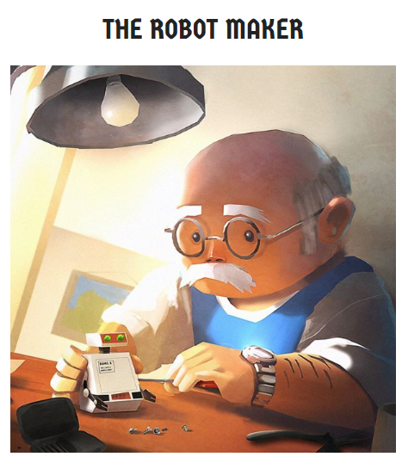
What does this robot do?
Is the man building it or repairing it?
How does he feel about it? Is this one special?
Do you think he’s been a robot maker for a long time?
Is he good at his job?
What kind of person do you think he is? What are his likes/dislikes? Do you think he prefers to be around people or be alone?

Challenge…. – Write a story with the title The Robot Maker………………..
It is your story so the robot maker can be anyone or thing you want it to be. They can make any type of robot, the choices are endless.
Have a lovely day, year 2. We can’t wait till we are all back together again in class.

Tuesday 31st March 2020 Word of the week ‘Inspiration’.
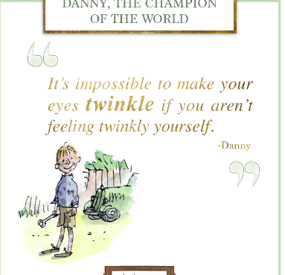Quote of the day – Roald Dahl
Good Morning, year 2, Happy Tuesday. Can you believe we are now on to day 7! How did you all get on yesterday? Good I hope! Spring has definitely sprung and today I thought it would be nice to look out of our windows and to be inspired to write a Spring poem

Can you remember the Polar Bear shape poems you did in January? They were all brilliant! You are very good at them. Today we are going to write Spring shape poems.

Task: Have a look outside what can you see? Can you create a word bank of ‘spring’ vocabulary. e.g tulip, daffodil, birds, chicks, blossom, rainbows…………. The list is endless.
Once you have your word bank off you go. I have written two WAGOLLs to give you an example. I chose a flower shape but what about a chick or a lamb, or an egg shape?

NMP Feeling confident/challenge me.

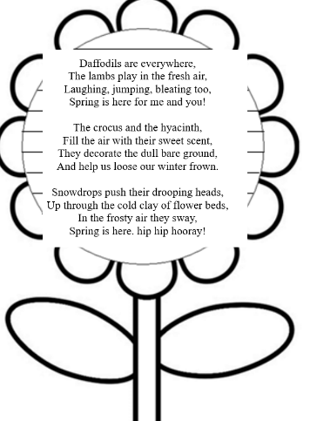
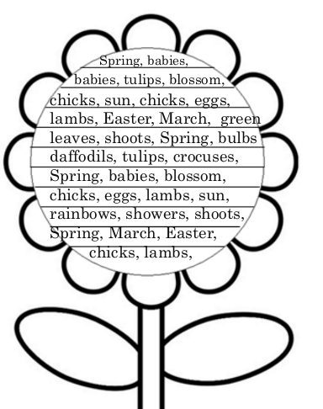
WALT create a shape poem.
Challenge me – use alliteration. Feeling confident – include capital letters, full stops, exclamation marks, NMP – use Spring themed words.
Have a lovely day year 2, don’t forget we are all so proud of you all! Can’t wait to be back together in class.

Wednesday 1st April 2020 Word of the week ‘Inspiration’.
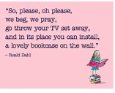
Quote of the day by Roald Dahl
Good Morning, year 2. Welcome to WOW Wednesday, day 8! Can you believe we are already in April? I hope you had fun writing your shape poems. I shall look forward to reading some of them soon. Today I thought it would be nice to share a ‘Spring’ story. We miss reading with you. Today’s story is a ‘fairy story’ and was written by a famous story teller Hands Christian Andersen. He was from Denmark and when I was a little girl I loved his stories my favourite was ‘Thumbelina’!
WALT identify nouns, verbs and adjectives.

The Proud Little Apple Blossom by Hans Christian Andersen (adapted)
It was the month of May, but the wind still blew cool, for the sun was not yet ready to shed his warmest rays on the waiting earth.
Yet some of the birds had come, and more were on their way, and many beautiful blossoms were already showing their pink and white blooms, so that from bush and tree, field and flower, came the glad cry, "Spring is here! Spring is here." Now, it happened that a young princess rode by a beautiful orchard in full bloom, and she stopped to pick a branch of apple blossoms to take to her palace. All who saw the apple blossom praised its beauty and fragrance until the blossom became proud, and thought that beauty was the only valuable thing in the world. But as the apple blossom looked out upon the field she thought, "Not all of the plants are rich and beautiful, as I am, some seem poor and plain." And she noticed a little, common, yellow flower, which seemed to lift up its sunny head and grow everywhere.
The apple blossom said to the plain little flower, "What is your name?"
"I am called the dandelion," replied the little flower.
"Poor little plant," said the apple blossom. "It is not your fault; but how sad you must feel to be so plain and to bear such an ugly name."
Before the little plant could reply a lovely little sunbeam came dancing along and said, "I see no ugly flowers. They are all beautiful alike to me." And he kissed the apple blossom; but he stooped low and lingered long to kiss the little yellow dandelion in the field.
And then some little children came tripping across the field. The youngest laughed when they saw the dandelions and kissed them with delight. The older children made wreaths and dainty chains of them. They picked carefully those that had gone to seed, and tried to blow the feathery down off with one breath, making joyous wishes.
"Do you see," said the sunbeam, "the beauty of the dandelion?"
"Only to children are they beautiful," said the proud apple blossom.
By and by an old woman came into the field. She gathered the roots of the dandelions, out of which she made tea for the sick, and she sold others for money to buy milk for the children.
"But beauty is better than all this," still said the proud little apple blossom. Just then the princess came along. In her hand she carried something that seemed like a beautiful flower. She covered it carefully from the wind. What do you think it was? It was the feathery crown of the dandelion. "See!" she said, "how beautiful it is! I will paint it in a picture with the apple blossoms."
Then the sunbeam kissed the apple blossom, and as he stooped low to kiss the dandelion the apple blossom blushed with shame.

Can you underline the nouns, verbs and adjectives in the story? If you are finding it hard read through with your adult. Let them identify the nouns, verbs and adjectives. See if they are correct, challenge them to explain why.

Nouns – name, place, item, e.g Apple, princes, tea, milk,
Verbs – doing words, stooped, kissed….
Adjectives – describing words – feathery, proud……..

Challenge me. Can you identify other stories by Hans Christian Andersen. Why not see if you can read one on line?

I hope you enjoy this story and that it inspires you to read more of Hans Christian Andersen’s stories. I am sure your adults will be able to share their favourites too.
Speak tomorrow and keep well.

Thursday 2nd April 2020 Word of the week ‘Inspiration’
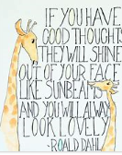

Good morning year 2. Today is day 9!! What lovely weather we had last week. Today we would have been doing P.E this afternoon, so make sure you try to do some exercise today. Get out in the garden if you can or put the Kidzbop dance tutorials on youtube. Keep moving…
I thought today we could do a diary entry. I am sure some of you have already started one but I thought I could write a diary entry too. I will look forward to reading all of yours when we get back to normal. This is my diary entry from last Tuesday.

Tuesday 23rd March 2020

Dear Diary
When I woke up this morning the sun was shining brightly through my windows and the cloudless sky was bright blue! Immediately I felt my spirits lift and I was inspired to get up and get on with today’s tasks. Freddie and Drew were still in bed and I decided to let them have a lie in.
I had already decided yesterday that I was going to get outside as much as I could in the garden. I hung out all the washing and then sat on my patio drinking my coffee listening to the birds singing all around me. I am very lucky to live in the countryside with open fields at the back of me, that I can walk the dogs in without seeing a soul.
Fenella decided to do her work out in the garden and we all had a good giggle at her squatting and huffing and puffing. Ghost thought it was great fun, leaping on top of her, much to her annoyance.
After lunch I sat down in the kitchen with the lap top and did some school work. It was nice to look forward at some of the things we will be looking at after Easter. I hope the children have some Roald Dahl books at home, they are lovely stories and I can think of lots of great activities we can do. I also had a look at some of the Eric Carle stories on line, my favourite is The Very Hungry Caterpillar but I also love The Very Angry Ladybird!
Freddie and Drew wanted to play football in the garden after their lunch, so I decided to cut the grass. Ghost goes mad at the lawnmower and tries to bite the wheels, so he had to go inside till I had finished. It was so warm that I enjoyed the luxury of sitting in my swinging chair that hangs from the big, fir tree. For a few minutes I was able to escape in my reading book, it was bliss!
So all in all, not a bad day! I wonder what I will get up to tomorrow and will the weather last?
Mrs Johnson

Task: Can you write a diary entry?

Don’t forget our diary success criteria.
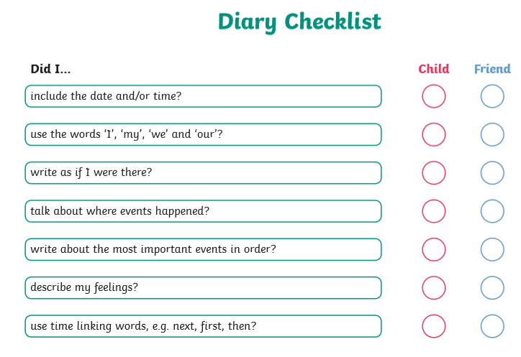
I am looking forward to reading these when we get back together and I think it would be nice if we could write a diary entry every week. So this will be our regular Thursday task. Have fun today and keep well.

Friday 3rd April 2020. Word of the week ‘Inspiration’.
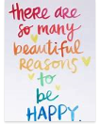
Good morning Year 2. Day 10! Today would have been our last day before the Easter break. I hope you are still able to eat lots of chocolate eggs over the next two weeks and I will make sure we have something nice when we get back to school. I thought today it would be nice to write an Easter poem. We have already done a shape poem this week so I thought today we could try an acrostic poem.

What is an acrostic poem?
It is a poem that uses the letters in a topic word to begin each line. All the lines of the poem should relate to or describe the topic word.
Here is one I have written…
Easter
E aster eggs brightly coloured,
A ll the lambs dancing in fields,
S leepy animals waking up,
T he blossoms budding on trees,
E very bird singing a sweet song,
R abbits racing through grass
Easter

Here are some Easter themed words to help you.

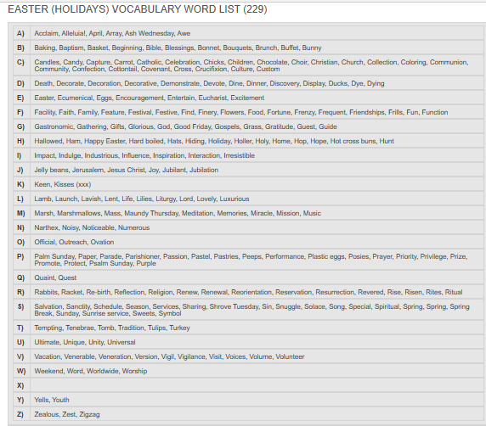

If you think this will be too difficult, then why not just create a word bank of your favourite Easter words, that will be a poem in itself.Have fun and I look forward to reading them. Why not draw an Easter picture to go with your poem. Or create an Easter themed page border. Don’t forget to check for capital letters and full stops. If you can use a dictionary for tricky words. Enjoy and try to have a lovely Easter with your closest family.

