Wednesday 6th May 2020
SPaG
Spellings - The u sounds spelt ou.
Write each word in your spelling list using two different colours. Write the constants in one colour and the vowels in another colour.
Young
young
touch
double
county
trouble
cousin
encourage
flourish

Word of the Day – crafty

Definition ____________________________________________
_____________________________________________________
_____________________________________________________
Used it in a sentence: ____________________________________________________
_________________________________________________________________________
Word Class: ____________________________________________________
Synonyms

English
Do you know the traditional Cinderella story?
You can remind yourself by reading it (if you have a copy at home) or listening to one on You Tube e.g https://www.youtube.com/watch?v=Q8giBVshTiQ
Then if you need to listen to the Egyptian Cinderella again https://youtu.be/kqrnP7Julxw
Today’s work is to compare the two versions of Cinderella – I have completed some of it for you. You can copy the chart into your own book / paper.
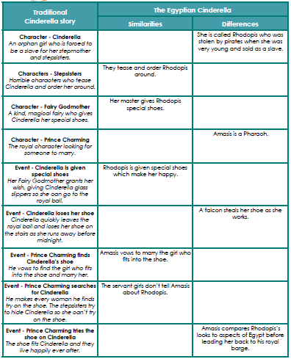
Maths – Mental
1) How many seconds in ¾ of a minute?
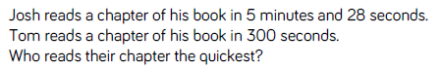
2)

Maths – Main Lesson - Decimals
Watch : https://www.bbc.co.uk/bitesize/guides/z27xsbk/video
Take care when reading the values of decimal numbers.
- 4.2 means 4 and 2 tenths.
- 4.20 means 4 and 2 tenths and 0 one-hundredths. The last zero does not need to be there.
- 4.02 means 4 and 0 tenths and 2 one-hundredths.
1) What is the value of the underlined number. You must choose from: tens, ones, tenths or hundredths.

13.64, 42.36 24.17 11.55 23.35

2)

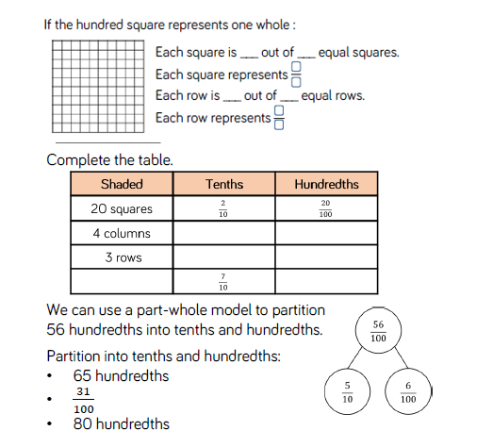
PSHCE - Emotional Check in
How are you feeling today?
Circle the face you think best represents how you are feeling.
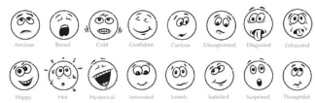
Write the word or words which you think best describes it
________________________________________________________________________
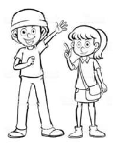
Do you know why you are feeling the way you are feeling? If you do, write that down too.
_________________________________________________________________________

It is important to name the feelings to help us process and deal with them, and talk to someone you trust!

Looking to the future…
It’s always exciting to have things to look forward to, it helps our minds to stay positive. Take a few moments to think about what you are looking forward to when schools go back. Jot them down below:

