Year 2 Phonics/Spelling Practice – Thursday 11.6.20.
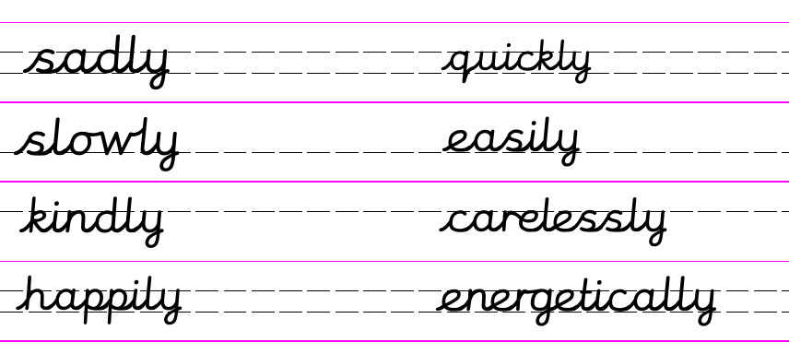
The verbs and the adverbs are all mixed up! Find all the adverbs and circle them.
quickly sneakily walked
ran bravely widely
jumped skipped happily
swam crawled kindly
spoke greedily crazily
sang watched
Write a sentence to explain what an adverb is:
An adverb _____________________________________________________
__________________________________________________________________________
Write a sentence to explain what a verb is:
A verb is _____________________________________________________
__________________________________________________________________________
Dictation sentence to write from memory:
The children played happily and energetically in the grass.

Maths 11.6.20
Odd and even numbers
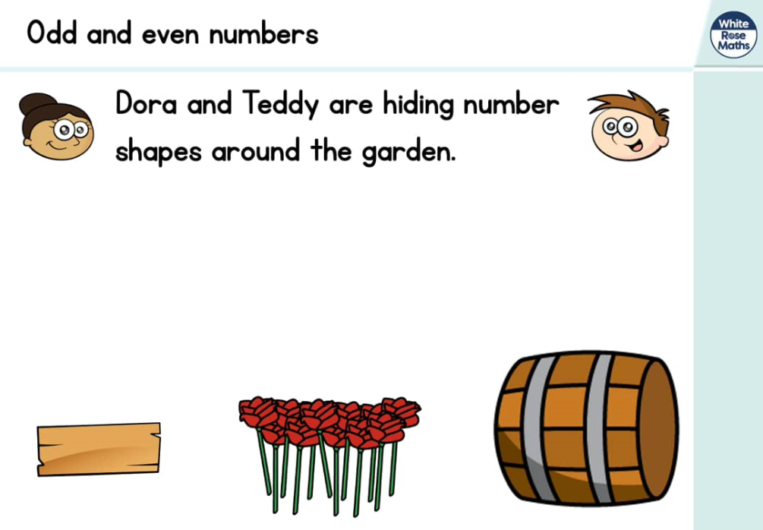
https://whiterosemaths.com/homelearning/year-2/ (Week 6 W/C 1.6.20)
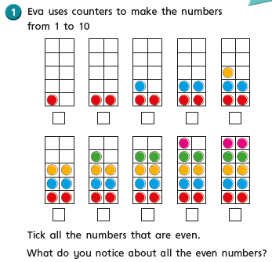

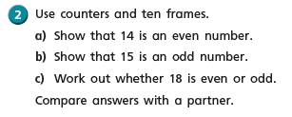
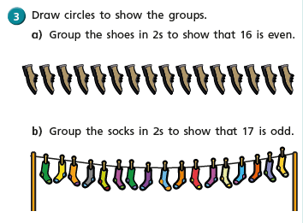
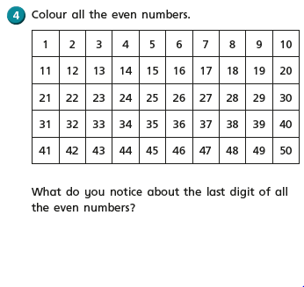
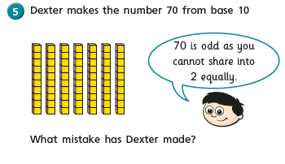

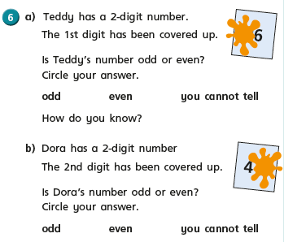
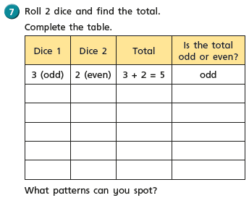

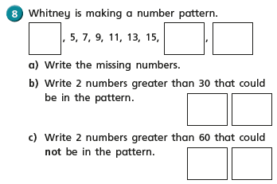

English - Thursday 11th June 2020
WALT write a description of a scary setting using similes, repetition and metaphors..
WILF I can use repetition to add suspense.
Word of the day repetition/suspense.

Good morning.

On Tuesday you started to write your scary setting, based on ‘The Wild Woods’. Today I would like you to finish writing your setting or to edit it.

When you are editing, remember to read it through first, perhaps to an adult or one of your siblings. Does it always make sense?
Now can you improve it. Have a look at any spellings you weren’t sure of, use a dictionary to make sure they are spelt correctly. Have you used any adjectives to describe? Are they the best ones you could have used? Use a thesaurus to find synonyms that may improve your work. Have you used repetition to add suspense? Make sure you haven’t repeated the wrong types of words e.g then, after,

Are you pleased with your improved work?

Art - Thursday 11th June 2020
WALT: make story stones.

As part of our Countryside tales topic, we are going to look today at some Nature Art. Last week we looked at the artist Andrew Goldsworthy, who uses art in nature. Did you manage to make an outside art sculpture?

Today I thought it would be nice to make some story stones based on Wind in the Willows. You could draw pictures of Toad, Mole, Badger, the wild woods, Toad Hall, the caravan, anything you wish from the story.
Stone has been used in art for many thousands of years.
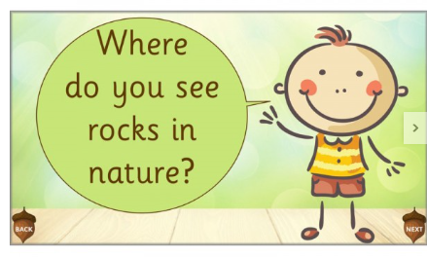
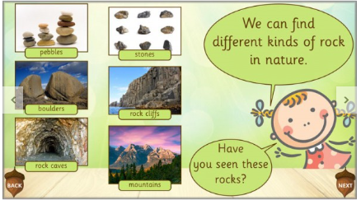
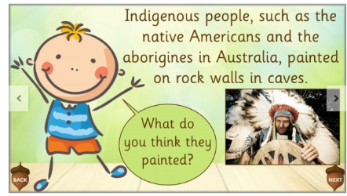

Hopefully you can find some stones to paint/draw your ‘Wind In The Willows’ art on. If not, don’t worry just draw some stone shapes on paper and then draw in the space.
Have fun. I hope I get to see some of your work.

