Monday 20th April 2020 – English
SPaG
Spellings - The prefix im before a root word starting with m or p

important - _______________________________________________________________
imperfect - _______________________________________________________________
improper - ________________________________________________________________
impolite - _________________________________________________________________
impossible - _______________________________________________________________
immature - ________________________________________________________________
immeasurable - ___________________________________________________________
impatient - ________________________________________________________________

Look up the meaning of each of these words in a dictionary so you understand what each word means.
Word of the Day – mistrust

Definition ____________________________________________
_____________________________________________________
_____________________________________________________
Used it in a sentence: ____________________________________________________
_________________________________________________________________________
Word Class: ____________________________________________________
Synonyms

English – Read the text again that we last looked at before Easter.
The Sky Turtle
Flight
The sky turtle is well-adapted to its environment and can breathe, and fly, at very high altitudes. Turtles use strong muscles, located in their chest, to ‘flap’ their flippers and give them the thrust to move through
the air. Their lightweight shells and hollow bones make it easier for them to take flight and stay airborne, whilst their streamlined design makes them the perfect shape to move through the air with ease. Incredibly, the turtle can remain in the air for lengthy periods of time (several hours) though they tend to only do this while migrating and must ingest 3-4kg of insects as they fly. Without eating as they fly, the sky turtles would need to keep stopping to find food on the land.

Sleep
Whilst in flight, it is essential that sky turtles take it in turns to form small groups (around 3 to 4 animals) and allow the weakest in the group to take short sleep breaks on their backs. They do this to keep going over
longer distances. At night, they often roost in trees and often use the abandoned nests of dragons to stay safe.

Predators
Unfortunately, sky turtles form part of the diet of air orcas, and their shells, despite being strong, are no match for the teeth of an adult shark.

Did you know…
A sky turtle can reverse in the air by altering the direction that their flippers flap.

Use the grid on the next page to help you sketch the sky turtle – divide a sheet into a 6 squares by 6 squares if you don’t have a printer. Use the information in the sky turtle text to help you add labels to your diagram.

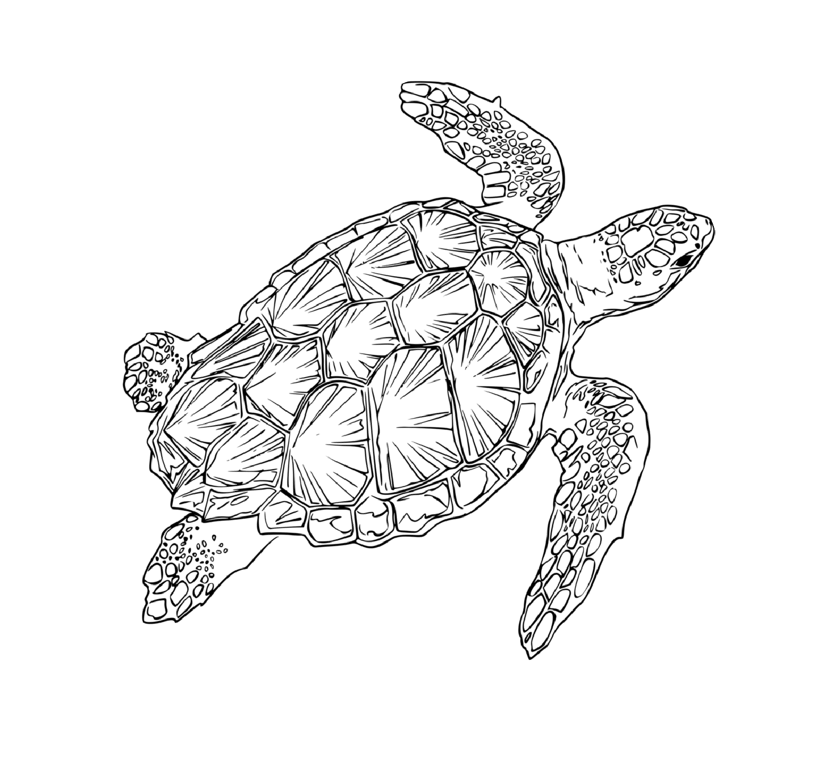

Maths – Mental
- 36 x 4 =
- What is the time 20 minutes after ten minutes past seven?
- How many grams in ½ kg?
- ¼ of 32 =
- How many grams in ¾ kg?
- 6 x 6 = ? x 12
- 200 – 21 =
- 354 + 528 =

Maths – Decimals
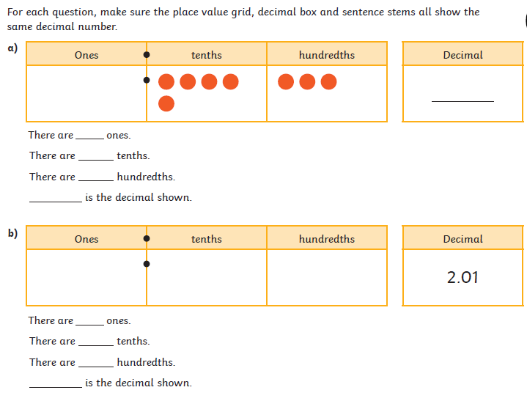

History/Geography
It’s a new term and a new topic! Welcome to ‘Tomb Raiders’! We will be becoming familiar with the Ancient Egyptian civilisation, looking at mummifications, pyramids and the River Nile to find out about life in Ancient Egypt from the evidence left behind. Let’s get started!
- Firstly, think about what you already know about Egypt. Is there anything you would like to find out? You could begin by researching the questions you have.

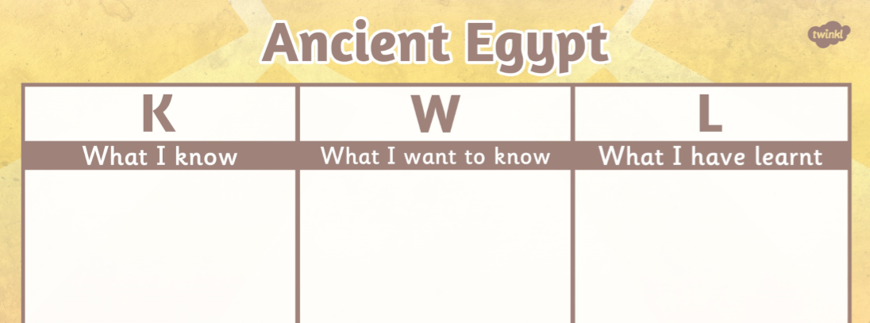

- Can you find out:
- Where is Egypt?
- Whereabouts in Africa is Egypt located? (use the compass points)
- What is the capital city?
- Which seas border Egypt?
- Which lake lies to the South of Egypt?
- What is the name of the river that runs through Egypt?
- Which cities are the airports located in Egypt?
- Which Seas border Egypt?

