Tuesday 28th April 2020 Year 2 Phonics/Spelling Practice – w 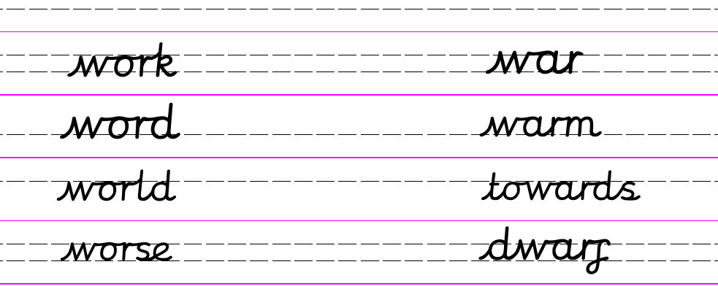
Which word goes with which picture?
word, work, worm, world, worth, worse, worst.

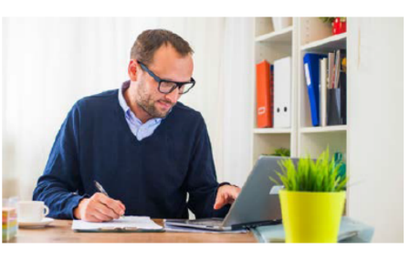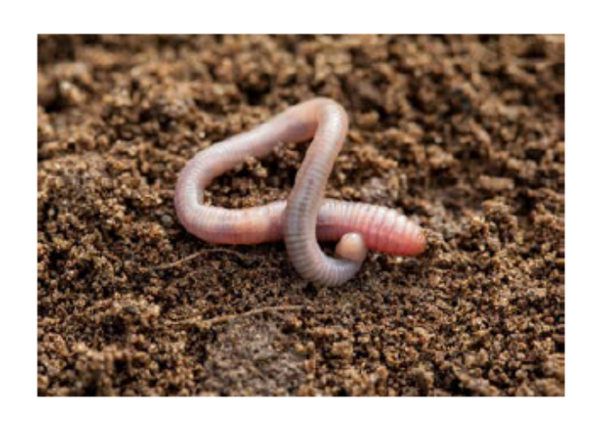

Dictation:
Ask someone to read out the sentence below so that you can write it down – try not to look until after you’ve written it. Check your punctuation and spelling.
The world is full of worms that are on the path and grass.

Maths 28.4.20
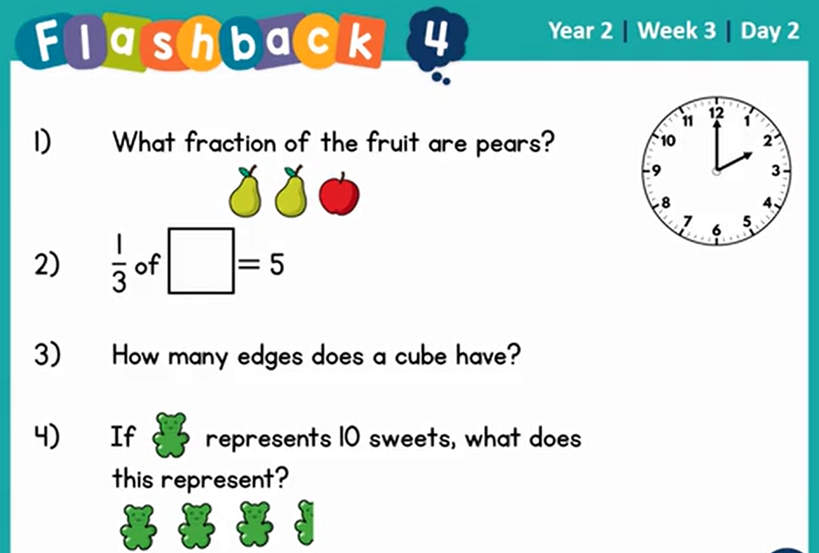
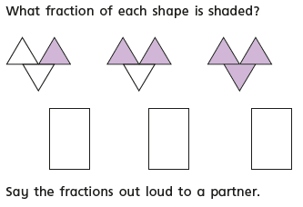
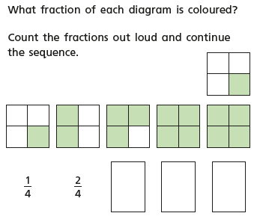
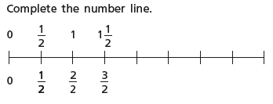
28.4.20 – English Word of the week – cautiously.
Good Morning, year 2. Today’s task is all about The Girl on a Dragon. We know how much you enjoy looking at images and using your reading comprehension skills, our VIPERS. Vocabulary, inference, prediction, explain, retrieve and sequence. I also know how much you love dragons. I hope you enjoy this one.
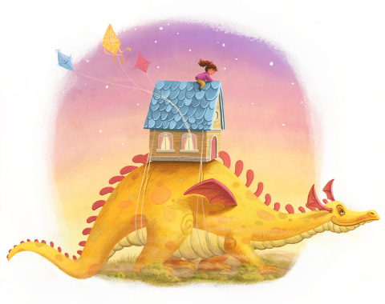
What happened before this picture?
How did the house get on top of the dragon? Who tied it onto the dragon’s back?
Is the dragon happy about this?
How do the girl and the dragon know one another?
Why is the girl sitting on top of the house and not inside it?
Where did the kites come from?
Where are they going?
Can you give the picture a more interesting title?
Challenge me: Write a story all about the girl and the dragon.
Have fun, do what you can. You are all amazing and I cannot wait to see you all soon.

28.4.20 – History
WALT understand the significance of historical events in our locality.

How did you get on with last week’s task ‘All about me’? Whatever you wrote is now part of history, it is a primary source of historical evidence. We have talked about primary sources before at school when we looked at Samuel Peeps diary. Can you remember what a primary source is?

A primary source of evidence is an artefact, document, diary, manuscript, autobiography, recording or any other source of information that was created at the time under study.

Today I thought it would be nice to write about how we are all feeling at this time.

I am feeling hopeful and positive that soon we will all be back together at school. I am feeling grateful that my family and friends are all safe. I may not be able to see my parents or my sisters but how fortunate are we to be able to talk or the phone or see each other through facetime. I am feeling thankful that I have a nice home to spend this time in, that the weather has been so nice and I have been able to get outside in the garden. There are so many things to feel thankful for at the moment. I do feel sad that my son Harry is not at home with us at the moment but I know he is working hard and that he too is safe and well. We are all allowed to feel sad at times and worried but we have so much to be happy about too. I cannot wait to be back at school. I am looking forward to seeing all my family and friends and being able to give them a huge hug. I am looking forward to visiting the beach and dipping my toes in the sea.

I want to know how you are feeling. I want to know what you are excited to do when we are out of lockdown. I want to know what you are thankful for and what you have learnt from being at home.

I have attached a copy of a template that you could use but as I said last week you can make up your own or even record your thoughts on the ipad or on a phone.

I look forward to seeing what you have written/recorded as soon as it is possible for us to be back together in school. Have fun! Remember you are living history and this is your chance to create the primary sources that historians will study in years to come.

