Friday 24th April 2020
SPaG
Spellings - The prefix im before a root word starting with m or p
Practise your spellings
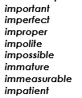

Use all the words in your spelling list to write a story. Underline the words from your spelling list using a ruler.

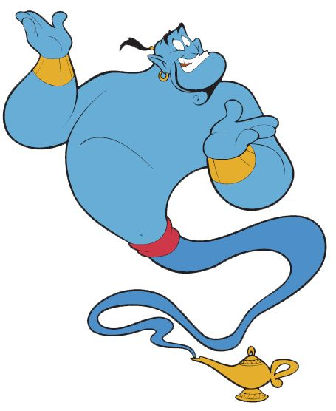
Word of the Day – release

Definition ____________________________________________
_____________________________________________________
_____________________________________________________
Used it in a sentence: ____________________________________________________
_________________________________________________________________________
Word Class: ____________________________________________________
Synonyms

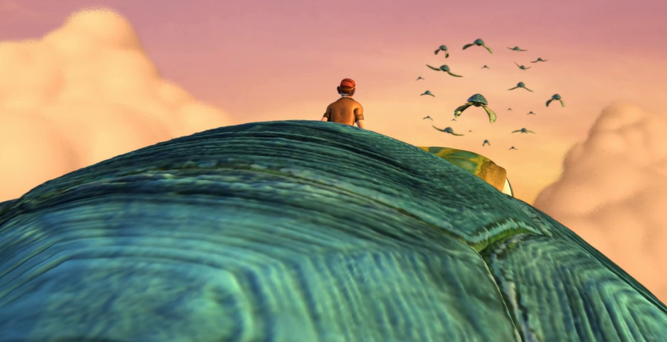
English – Can you write an ending to the story, where do these turtles take him? Use DADWAVERS!

Maths – Mental
- 656 + 572 =
- 1000 – 501 =
- Sarah has a £5 note, she buys chocolate which costs £2.20, how much money does she have left.

- 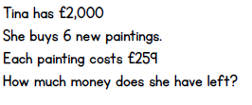
5 x 364 x 2 =

- 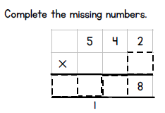
I think of a number, I multiply it by 52, my answer is 208, what was my number?
- 160 x 3 =
- The rubrics cube has 9 squares on each face, how many squares has it, in total?
Maths – Decimals
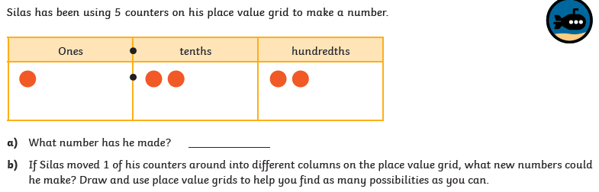

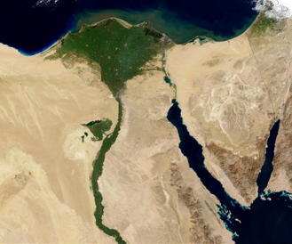
Geography
Over 90% of Egypt is covered by desert, which was often referred to as the Red Land and was not easily habitable. The River Nile was a major influence on the daily lives of the people. In ancient times, most of the population occupied the area on the banks of the river, the Kemet or Black Land, named after the dark silt that remained when the flood waters receded. This was where the farmers grew their crops.

- Look closely at the satellite image can you see the crops, desert and seas?
- Herodotus (450BC) called Ancient Egypt ‘the gift of the Nile’ do you agree with this?
- Complete the table on the next page to find out if the Nile has the same functions today as it did in the past.
