Year 2 Phonics/Spelling Practice – w/c 20.4.20 Day 1
Look at this week’s words – they all have the same ‘suffix’ or ending – est. This ending makes the root word stronger.
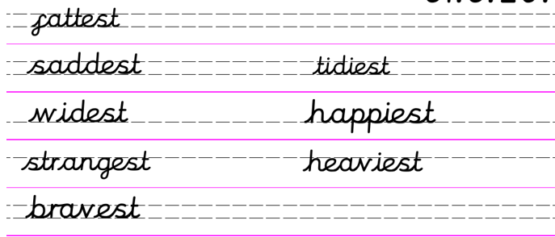
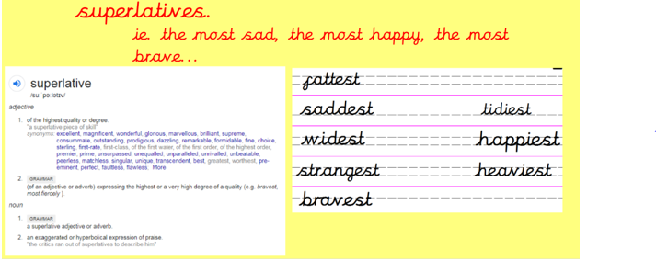
Practise copying this week’s words and write them out in your best Russell handwriting.
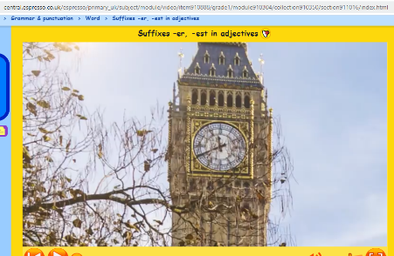
Use Look – Cover – Write – Check method.If you can access Espresso – try watching this video to find out more.
https://central.espresso.co.uk/espresso/primary_uk/subject/module/video/item910888/grade1/module910304/collection910350/section911016/index.html

English 20.4.20
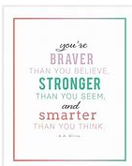
WALT identify and use interesting adjectives.
Word of the day: wisdom.
Good morning year 2, I hope you all had a lovely Easter and are all safe and well. How wonderful was the weather? Did you all manage to get outside in the sunshine? I had a lovely time with my family, walking the dogs and getting lots of gardening done. We even managed a couple of BBQ’s which I shall tell you all about when we write our diaries on Wednesday.
This week’s English includes a grammar lesson today, a viper lesson on Tuesday, Diary writing on Wednesday then on Thursday and Friday we are going to be looking at some of the stories by the author Eric Carle.
https://www.bing.com/videos/search?q=Were+Going+On+a+Bear+Hunt+Michael+Rosen&&view=detail&mid=4C189309870F414197014C189309870F41419701&&FORM=VRDGAR&ru=%2Fvideos
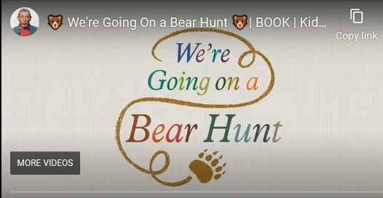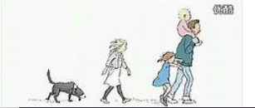
Parents – there are lots of copies of the story ‘We are Going on a Bear Hunt’ on youtube for you to enjoy with your child.
Read the story with your adult.
- Can you identify any features in the story?
- What is the same?
- What is different?
- Can you make up any actions to go with the story?
- Can you act the story out?
I hope you are using lots of expression whilst reading it! Are there any words that you don’t understand? If so ask your adult to explain or better use a dictionary. If you don’t have a dictionary there are plenty on line ones you could use.
“What is the mud like? It is thick and oozy.
Thick and oozy are adjectives. Can you remember what an adjective is? These adjectives are describing the mud. Why do we use adjectives?
If I asked you to pass me the blue crayon. Which word is the adjective? In this case the adjective gives you the information that you need to pass me the correct crayon.
I could hear the bear’s heavy footsteps coming through the cave. Here the adjective is heavy. The use of this adjective explains to me how the bear is walking down the path, I know he is not tip toeing.
Task
Today we are going on an adjective hunt and we’re going to find some great ones!
We’re going on an Adjective hunt…
Can you list as many adjectives as you can? You could look around the garden, go on your daily walk or just around the house.
Challenge me. Can you write a poem/rhyme in the style of Michael Rosen’s We’re Going on a Bear Hunt’? Here is the first verse of mine.
We’re going on an adjective hunt
We’re going to find some big ones,
Into the lounge, what can I see
A big, blue sofa with soft, squishy cushions,
a super soft rug,
A humungous, black television………….
What a cosy room
I look forward to reading yours.Have a super time on your adjective hunt!
Maths 20.4.20
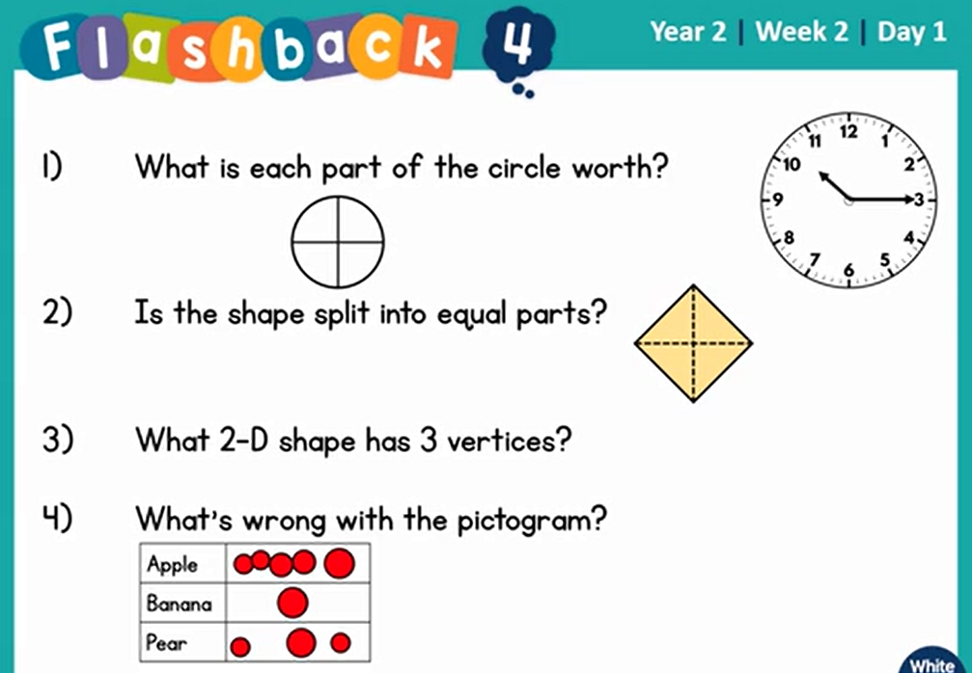
Copy and complete these number bonds to 100:
(A number bond is a pair of numbers that make another number e.g. 90+10=100).

20 + 60 + 90 +

50 + 70 + 10 +

80 + 30 + 40 +
Can you draw a regular shape to match these labels?
pentagon

circle
circle

rectangle

octagon

PSHRE 20.4.20

At school we have been thinking about all of the people that we trust. These are people that we know could help us if we felt that we needed help. It may be that we just need to share a concern or have someone to speak to. Today we will make our NETWORK HAND.
Each of our five fingers will represent a person that we trust. They will LISTEN TO YOU, BELIEVE YOU and HELP YOU.
Draw around your hand and decide on your five people to make your own network hand…

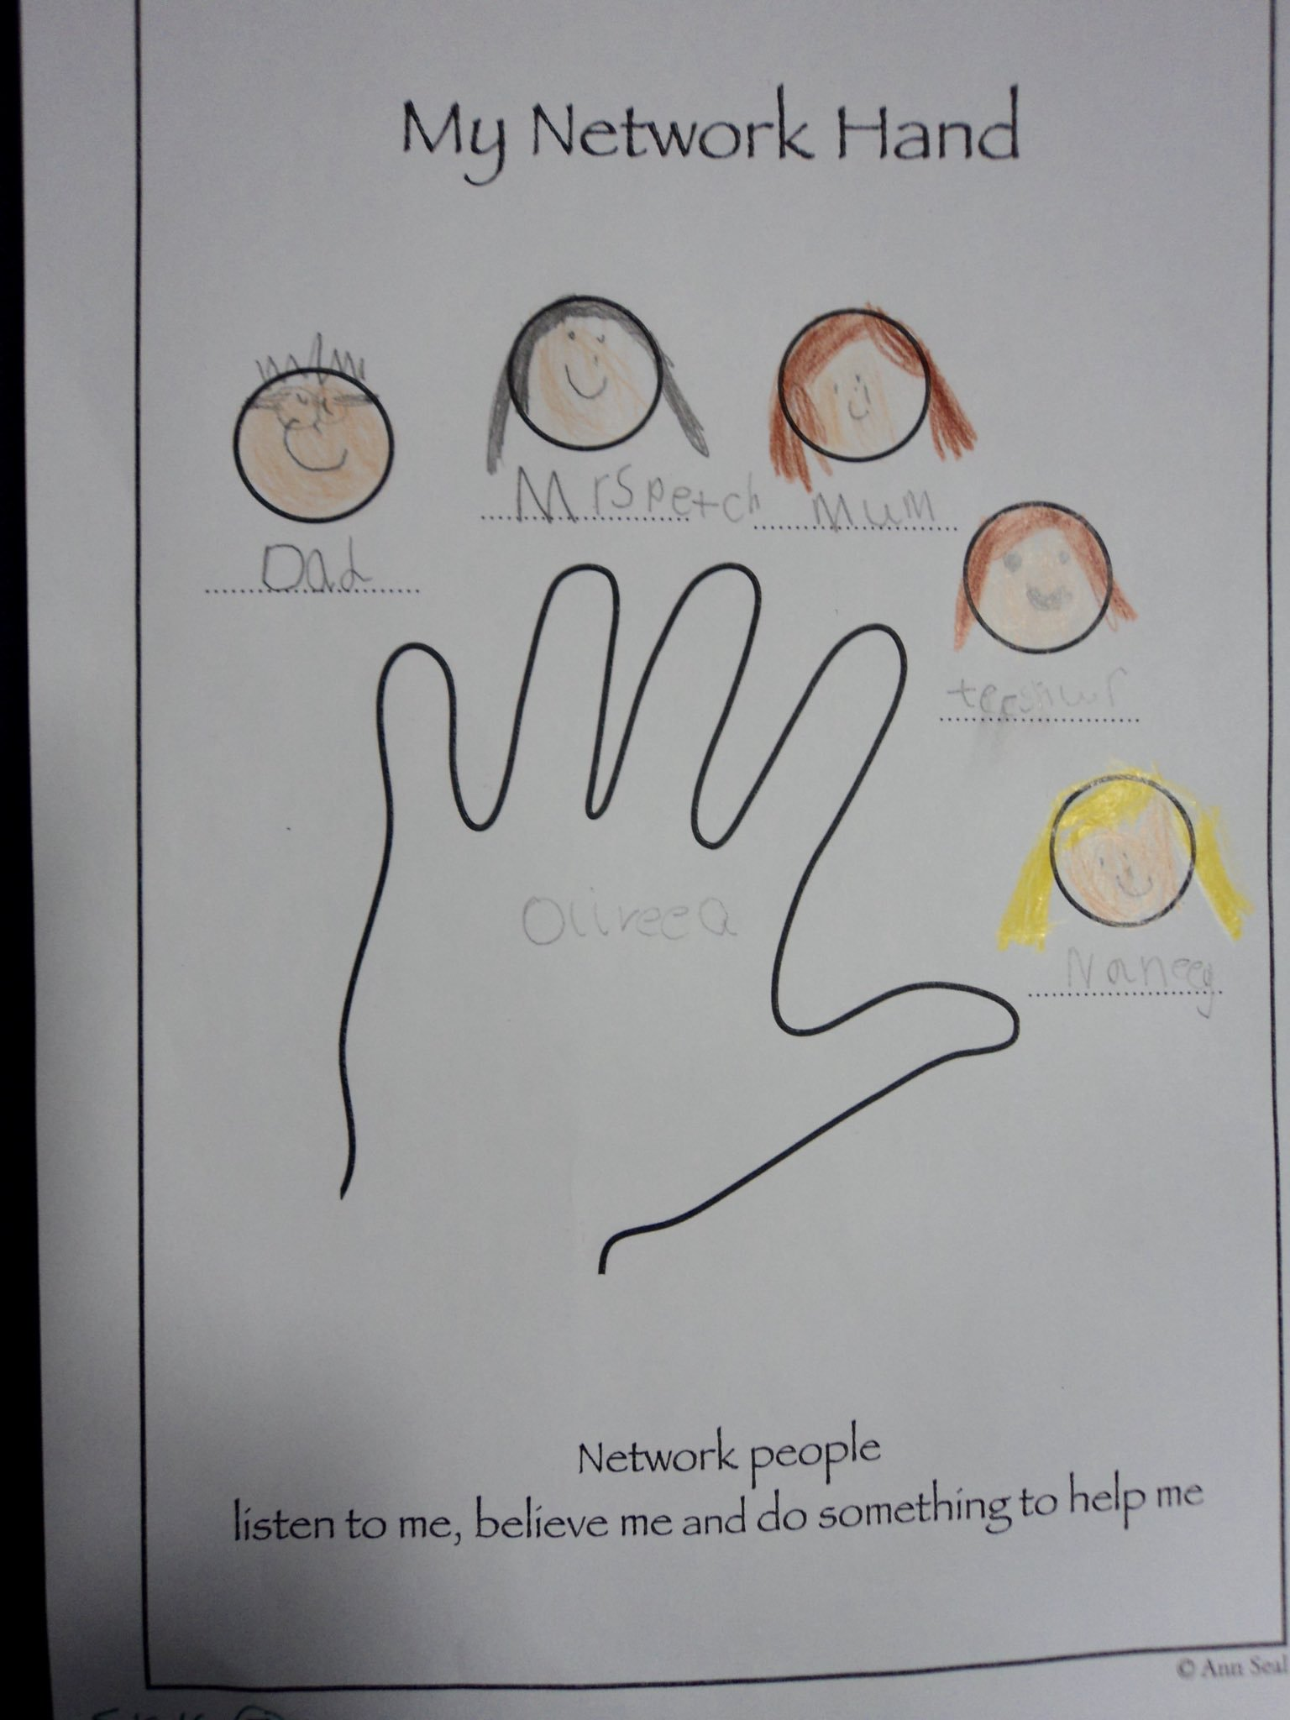
Music 20.4.20
FRIENDSHIP SONGS
We thought you might like to try listening to some music at home.
This term we will be listening to lots of songs about friendship.
Count on Me by Bruno Mars
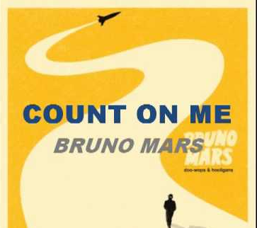
Listen to a recording of Count on Me by Bruno Mars – when you first listen try not to watch a video with it so that you can create your own pictures in your head.
https://www.youtube.com/watch?v=4JNtAtGGNRU (recording with video on Youtube)
Listen carefully. Perhaps close your eyes. Use your imagination as you enjoy the music. You might see colours, words, pictures, or encounter lots of different feelings. Play the music again. Move to the music or sit down to listen with closed eyes. What instruments can you hear? Perhaps use a piece of paper or Ipad/tablet to make notes, draw, write down any words that spring to your mind. You might want to create your own listening map - a visual representation of what they hear. (But you don’t have to!)
Questions to think about whilst you listen.
Does this song tell a story? Perhaps the words tell a story or perhaps the music creates a story in your imagination. What is that story?
What can you hear? Keyboard, guitar, Bruno Mars' voice, bongo drums. Some backing vocals and strings as the song progresses
How does the music make you feel? Music brings many emotions along with it and often each person feels something different. Perhaps share with someone how the music makes you feel.
What did you like about the song? It doesn't matter if you like or don't like a song or a piece of music. Think about the reasons why you do or don't.
Listening map example