Thursday 9th July 2020
SPaG
Words spelt with a g sound spelt gue
Write each word in your spelling list using two different colours. Write the constants in one colour and the vowels in another colour.
league
league
tongue
vague
plague
meringue
synagogue
epilogue
monologue

Word of the Day – resemble

Definition ____________________________________________
_____________________________________________________
_____________________________________________________
Used it in a sentence: ____________________________________________________
_________________________________________________________________________
Word Class: ____________________________________________________
Synonyms

English
Today you will be improving your playscripts. It often helps to perform a script to help spot areas that need to be improved. See if the people who you live with can help to act it out with you. Below is an editing check list to help you today.

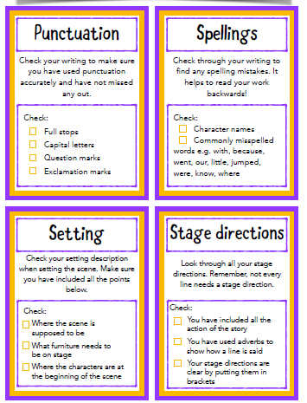

Maths
- 256 ÷ 100 =
- 56 ÷ 100 =
- 43 ÷ 100 =
Watch this video to remind you about solving problems with money.
https://vimeo.com/430337938
Use it for today and Friday’s work.
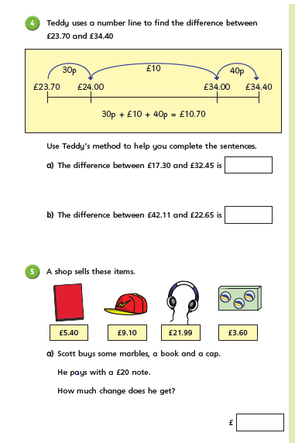
History
As we reach the end of our topic on Ancient Egypt, let us take a moment to think about what Egypt is like today and make comparisons between modern and ancient Egypt.
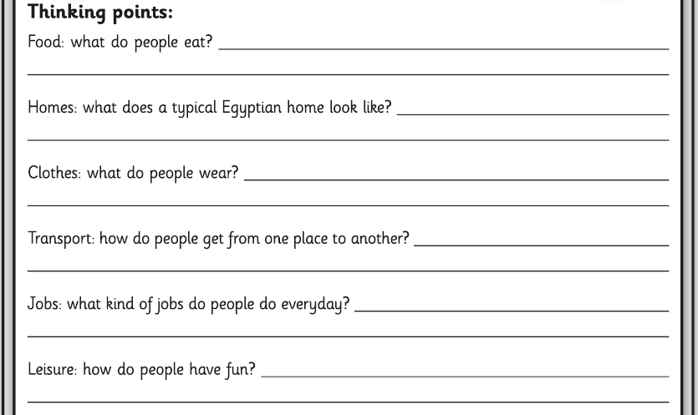
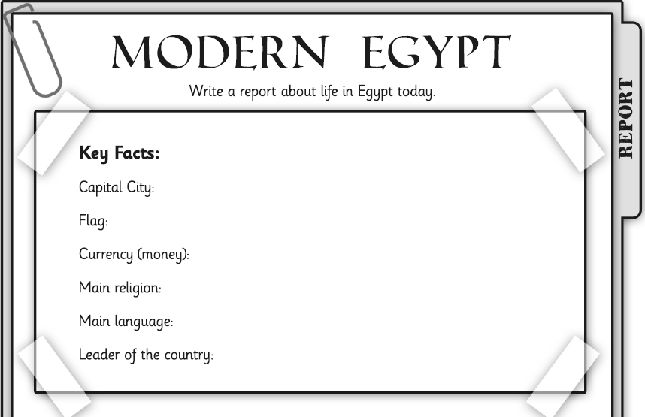
Challenge: Compare modern day Egypt with Ancient Egypt. What are the similarities and differences? Whick period would you prefer to live in, why?

