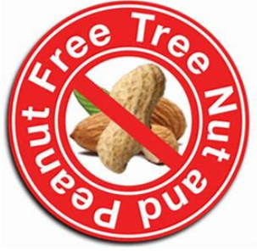

6th July 2020
Dear Parents and Carers,
IMPORTANT SAFETY MESSAGE
Please be aware that we have a number of both children and staff members with severe nut allergies in school. As a result, we are a nut and nut product free school. In other words, no nuts (of any type) or products that have nuts in them (please refer to the packaging) can be brought into school at any time, for any reason please.
People who suffer from nut allergies can develop a severe, potentially life-threatening allergic reaction.
If someone has a nut allergy it is not just eating nuts that can cause a severe reaction, just being touched on the skin or smelling the breath of someone who has had nuts or a product containing nuts can trigger anaphylactic shock (which can cause breathing and swallowing difficulties). First aid staff in the school are trained to use the Epi-pens (an injection of adrenalin) which is required immediately if this happens, but we never want to be in this position.
We cannot have nuts in school in any form. So please can we ask that you have no nut products at all in school (including in ‘private’ lunchboxes or snacks).
As I have said, as well as actual nuts, please be aware that many products ‘hide’ nuts. For example Peanut butter, chocolate spreads, cereal bars, granola bars, cakes that contain nuts and biscuits/cookies that contain nuts. This list is not exhaustive, so please check the packaging of products closely.
We appreciate that this is an additional thing to check, but we know that you recognise the importance of it. We do have to insist we are a nut free school.
Thank you so much for your support. If you have any questions, please do not hesitate to speak to a member of staff.
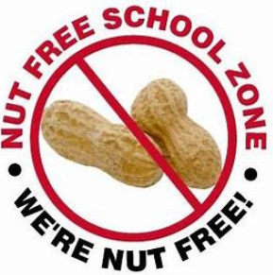
Many thanks and kind regards,
Nicki Walker
Headteacher

