Friday 5th June 2020
SPaG
Spellings – Suffix ly
Find the words in the word search

happily
angrily
gently
simply
humbly
nobly
frantically
dramatically

Word of the Day – represent

Definition ____________________________________________
_____________________________________________________
_____________________________________________________
Used it in a sentence: ____________________________________________________
_________________________________________________________________________
Word Class: ____________________________________________________
Synonyms

English
Today you will be writing a newspaper report about the death of Cleopatra VII. You can use the work you did yesterday to help you. Your writing needs to be set out in paragraphs.

You need to report the death of Pharaoh Cleopatra as if it were the day after it happened. These sentence starters might help you.

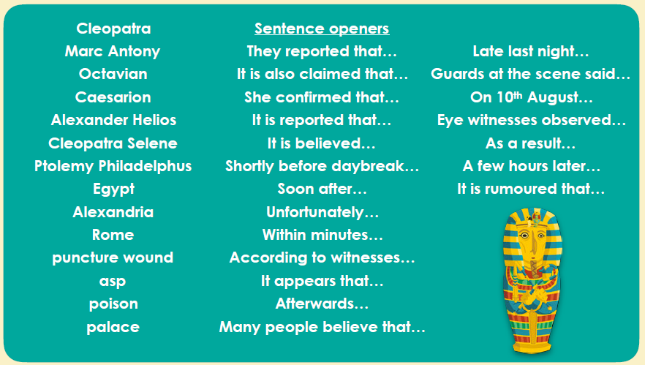

The writing frame below will help you set out your page.

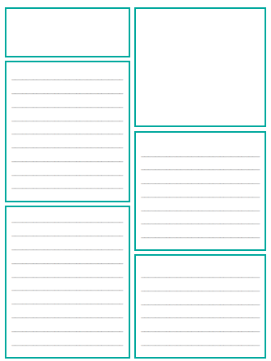
For a challenge instead of a written newspaper report you are challenged
to create your news report to be spoken aloud. First you will need to write a draft of your report. Think about how you could use varied sentence
openers and organising it into paragraphs to make it easier to
read. When recording your report, remember these tips:
•Practise how you want to say each paragraph before you record it.
•Speak slowly and clearly.
• Make sure you are not too close to the microphone.
•Try to record your report somewhere quiet without background noise.

Maths
Remind yourself about calculation methods we have learnt this year for multiplication.
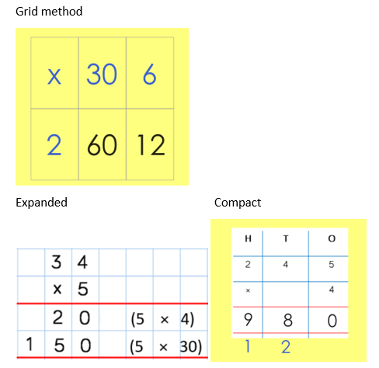
Use your preferred method to solve:
- 423 x 2 =
- 542 x 3 =
- 343 x 7 =
- 435 x 4 =
- 762 x 3 =
PSHCE
