To our lovely Puffins, Owls and Wren children,
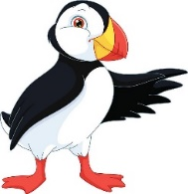

Hello everyone, how are you? We hope you are well and keeping yourselves busy. Thank you for trying hard with your learning last week, we hope you’ve enjoyed the activities that were set for you. We understand how different it is learning at home and as we take on the new challenge of home schooling our own children, we just wanted to say ‘well done!’
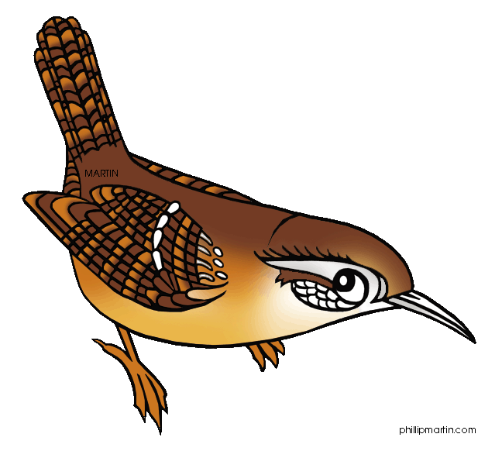
It seems very strange that we have not seen you all for so long. Your teachers have all been busy, spending some days at school, doing some work from home and also helping our own children with their learning. Although we have lots to do, we are still finding time to have lots of fun with our families – we hope you are too! Would you like to hear some of the things we’ve been up to during lockdown?

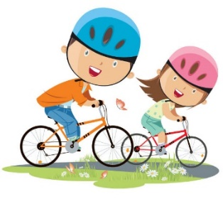
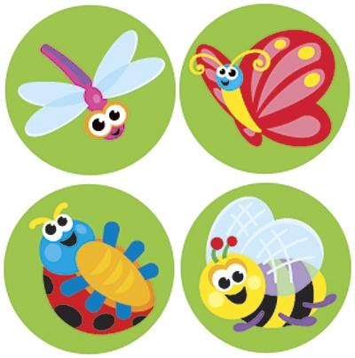
This week, Mrs Milligan has been doing lots of baking and taking part in competitive family netball challenges! Mrs Jochacy has been on a minibeast hunt with her boys and has enjoyed watching them have fun in the paddling pool! Mrs Cox has loved going on family bikes rides and long walks in the woods, looking at all the beautiful bluebells. Mrs Athanasiou has been planting seeds with the help of her children who have loved digging big holes, getting dirty and looking for treasure! We can’t wait to hear all your news the next time we see you!

Please find next week’s home learning pack attached to this letter. Remember to try your best, work hard for your grown-ups and just do as much as you can.
Take care everyone, keep smiling and enjoy a few of our favourite jokes each week at the bottom of our letters.
Mrs Milligan, Mrs Cox, Mrs Jochacy and Mrs Athanasiou xx
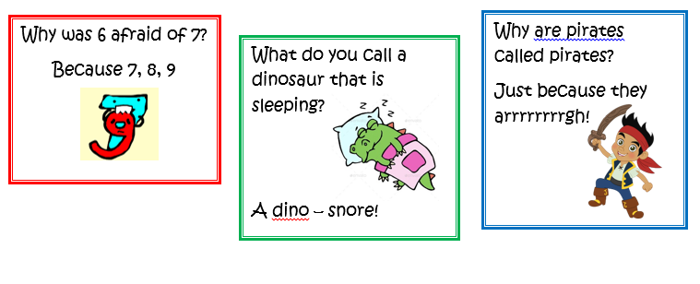
Year 1 Phonics activities – Summer 1 – Week 2 (w/c 27.4.20)
Session 1 - Monday 27th April 2020  Warm up activity - Log into ‘phonicsplay’ from the kids area on the website – then go to ‘resources/phase 5/flash cards speed trial/select phase 3 and 5a.’  Phase 3/5 sounds – speed practise recognition | Session 1 - Main activity  Play ‘yes/no yeti’ phase 5. Children to read the questions using their phonic knowledge and decide if the answer is yes or no.  https://www.phonicsbloom.com/uk/game/yes-no-yeti?phase=5  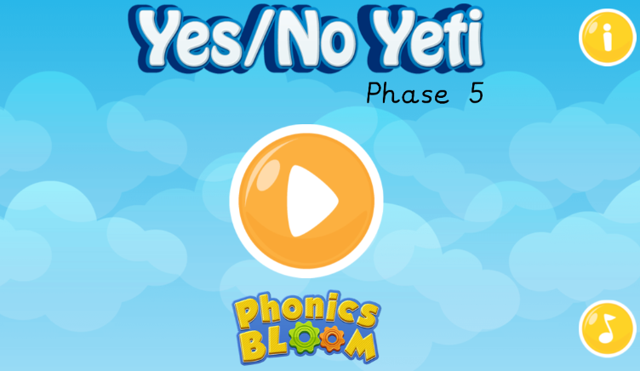  Children to have a go at writing their own yes/no questions for you to answer!
Session 2 - Tuesday 28th April 2020  Warm up activity - Log into ‘phonicsplay’ from the kids area on the website - resources/phase 5/Reading Robot/start/phase 5  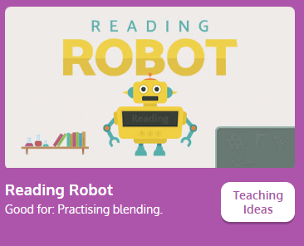 | Session 2 - Main activity  Play ‘hangman’ with phase 5 words e.g. shirt, treat, elephant, cloud, around, author etc.  When drawing the ‘lines’ you could draw a sound line for a digraph/trigraph and a dot (sound button) for 1 letter making 1 sound.  e.g. – ‘around’ . . __ . .  Children to guess and adult to write the letter/s at the bottom of the page/ board if it is incorrect and draw parts of the hangman picture. If correct write the letter/s in the correct place.
Session 3 - Wednesday 29th April 2020  Warm up activity– Phase 5 digraphs (2 letters together that make 1 sound)  Use the sound mat below– choose a digraph and ask your child to write it down/make it with magnetic letters/paint it outside on the pavement using paint brushes and water/chalk etc.  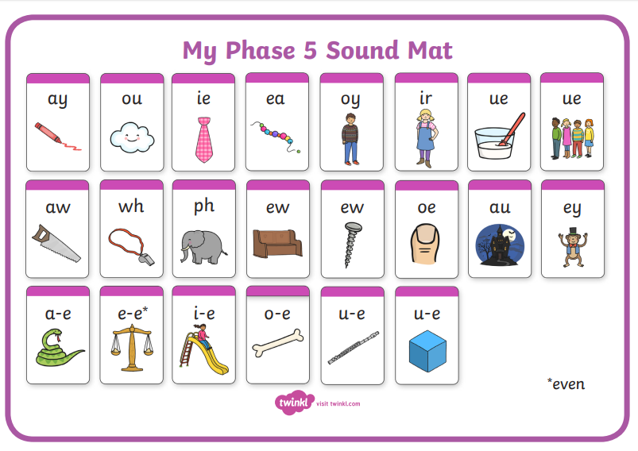 | Session 3 - Main activity  Use the phase 5 phoneme (sound) mat and children to choose one of the sounds.  Can they be a ‘sound detective’ and go around the house/garden and find different things that have that sound in them?  Can they write a label for the object?  Repeat with different sounds.
Session 4 - Thursday 30th April 2020  Warm up activity – Log into ‘phonicsplay’ from the kids area on the website - resources/phase 5/Dragon’s Den/start/phase 5/revise all phase 5  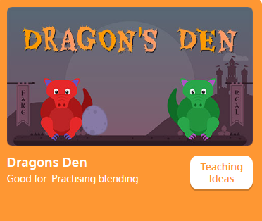 | Session 4 - Main activity  Children to create their own word search.  Use the phase 3 or 5 phoneme mat and children to choose digraphs/trigraphs and create their own word bank. Use these words to create their own word search!  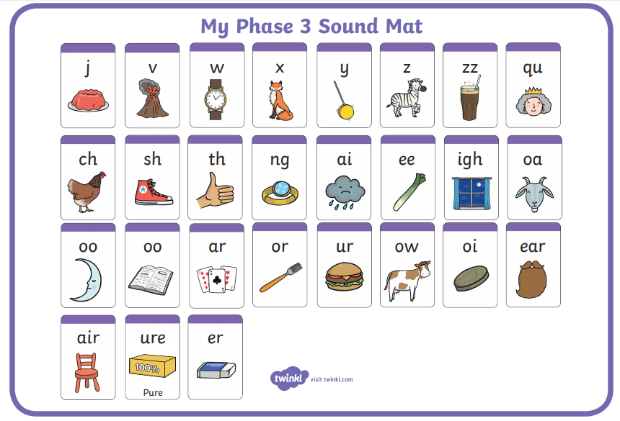
Session 5 - Friday 1st May 2020  Warm up activity - Log into ‘phonicsplay’ from the kids area on the website – then go to ‘resources/phase 4/Tricky word trucks/start/phase 4 –tricky words.’  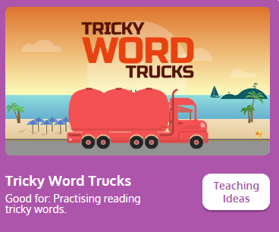 | Session 5 - Main activity  Children to choose words and think of a sentence.  Children to say the sentence and then write it down.  They could ask you to write their sentence down and then be the teacher and check it! Or you could think of a sentence, write it down and ask your child to highlight the tricky words they can see!  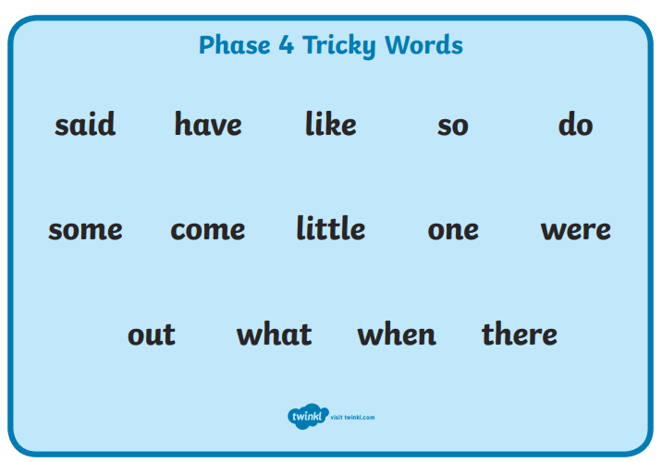

Year 1 English Activities – Summer 1 Week 2
Monday  27th April | Write a noun for as many letters of the alphabet you can. Remember is a noun is a person, place or thing.
Tuesday  28th April | Write a list of instructions for how to wash your hands. Remember to use time connectives (first, next, then) and ‘bossy verbs’ (wash, place, rinse).
Wednesday 29th April | Read a story aloud to someone in your family. Remember to use expression in your reading!
Thursday 30th April | Write some incorrect sentences for your child and ask them to correct them. Remind them they need capital letters for start of sentences and names of people and places, finger spaces between words and full stops at the end of the sentence e.g. the fat cat sat on the mat with a hat
Friday  1st May | Video of story  Espresso – KS1 – English – Books – videos – Mr Underbed  https://central.espresso.co.uk/espresso/primary_uk/subject/module/video/item1217575/grade1/module1217337/index.html  Comprehension questions  Espresso – KS1 – English – Books - Activities – Mr Underbed (Comprehension questions based on the story)  https://central.espresso.co.uk/espresso/primary_uk/subject/module/activity/item1218025/grade1/module1217337/index.html

Year 1 Maths Activities – Summer 1 Week 2
For this week’s maths learning, please go to the following link:
https://whiterosemaths.com/homelearning/year-1/
In the section Summer 1 – week 2 you will see a learning video for each day and an activity linked to it. Please don’t worry if you are unable to print the activity sheets but please read and discuss the questions together. Some of the questions can be done practically too (cube symbol on the worksheet). If you don’t have counters, you could use objects you have around the house e.g. small toys, coins, sweets, sequins, buttons etc.
The sequence of lessons is as follows:
Monday | Find a half (part 2)
Tuesday | Find a quarter (part 1)
Wednesday | Find a quarter (part 2)
Thursday | Problem solving
Friday | Friday Maths challenge

Year 1 Theme activities – Summer 1 Week 2
Date: | Activity:
Monday 27th April 2020 | Science – seasonal changes  Name the 4 different seasons. Can you write down what you know about each of them:  Describe what is the weather like in each season? What do animals do? What can we notice about the plants/ trees? Do we notice any changes in the length of the night and day?
Tuesday 28th April 2020 | Art  Create a seaside scene using a range of natural and man-made materials. Explain by writing down how you made your scene (what resources and technique you used).
Wednesday 29th April 2020 | Geography  Use world maps, atlases and globes to identify the United Kingdom and its countries.  Name, locate and identify characteristics of the four countries and capital cities of the United Kingdom, its surrounding seas and popular seaside locations.  Use basic geographical vocabulary to refer to key physical features and key human features of seaside locations.  Key physical features include: beach, cliff, coast, forest, hill, mountain, sea, ocean, river, soil, valley, vegetation, season and weather  Key human features include: city, town, village, factory, farm, house, office, port, harbour and shop
Thursday 30th April 2020 | History  Research what was Victorian Seaside Holiday like? In your own words write down what you learned about Victorian Seaside Holiday.  http://history.parkfieldprimary.com/victorians/victorian-seaside-holidays  https://www.youtube.com/watch?v=zWgnpY4L9so
Friday 1st May 2020 | PSHRE (Personal, Social, Health, Relationships and Emotional Development)  ‘Coronavirus – A book for children’  By E. Jenner, K. Wilson and N. Roberts  Illustrated by Axel Scheffler  Nosy Crow made this book quickly, to meet the needs of children and their families.  The book is written in a very simple and child friendly language. It explains what is Coronavirus, why are some places we normally go to closed, why we have to stay at home and be careful, what can we do to help and what is going to happen next.  https://nosycrowcoronavirus.s3-eu-west-1.amazonaws.com/Coronavirus-ABookForChildren.pdf

