Year 2 Phonics/Spelling Practice – Monday 15.6.20.
This week we are looking at when to use ‘a’ and when to use ‘an’ in a sentence. We call this the ‘indefinite article’.
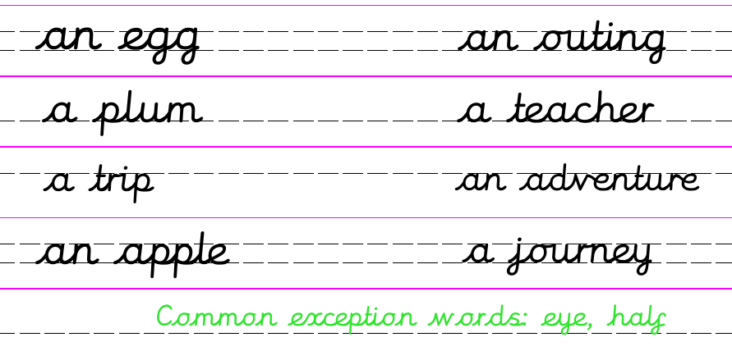
Practise writing your new spelling words each day using your best Russell handwriting.
The rule is simple – we use A when the word starts with a consonant and An when the word starts with a vowel.
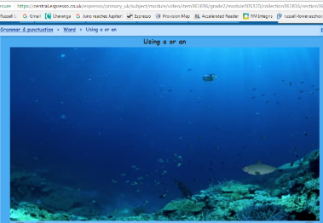
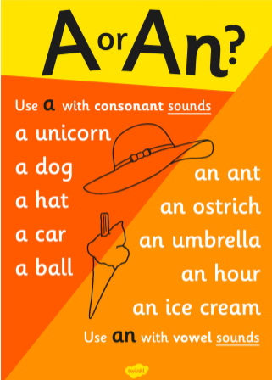
If you can access Espresso – watch this video

https://central.espresso.co.uk/espresso/primary_uk/subject/module/video/item361696/grade2/module305320/collection361816/section361777/index.html?source=search-all-all-all-all&source-keywords=using%20a%20or%20an

A reminder:
The five vowels are:
a e i o u

The consonants are the other letters:
a b c d e f g h i j k l m n o p q r s t u v w x y z

Dictation sentence:
Write out the sentence from memory:
I ate an apple and a strawberry as a snack.
Maths 15.6.20
Unit Fractions
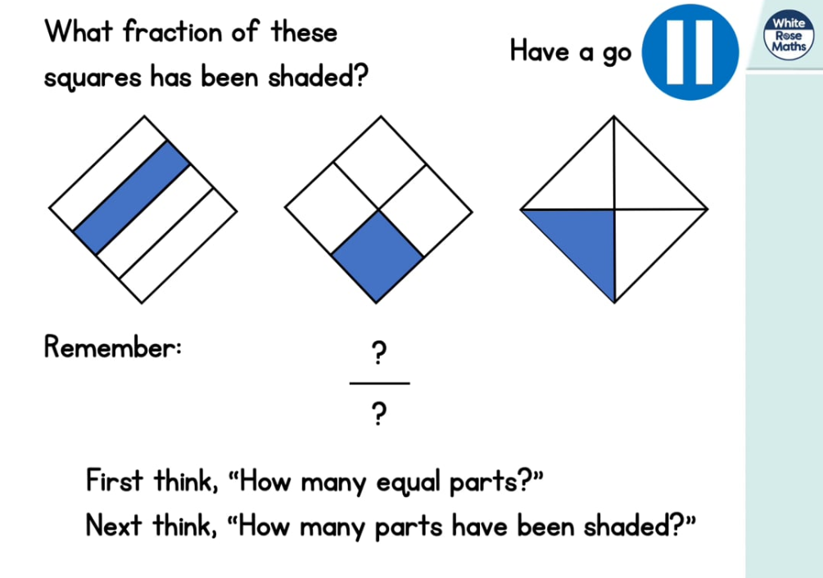

https://whiterosemaths.com/homelearning/year-2/ (Week 7 W/C 8.6.20)
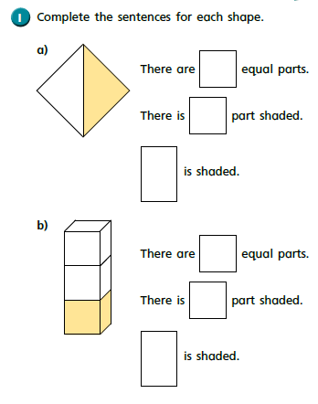
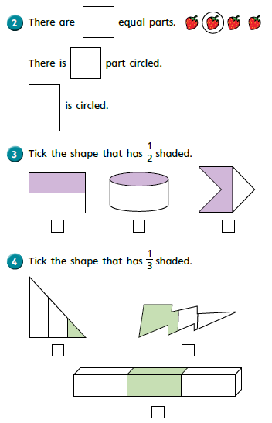

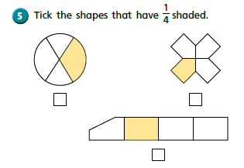
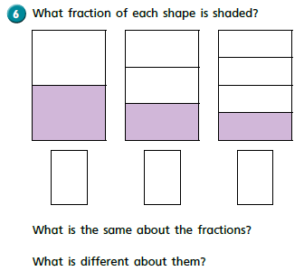

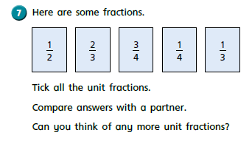
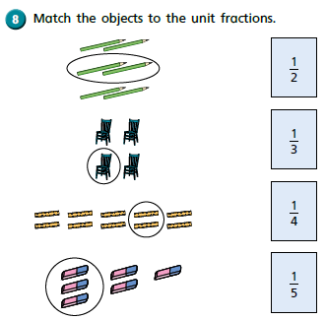
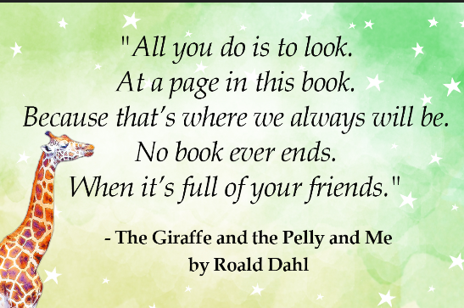
Monday 15thJune 2020 Word of the day: illustrator.
WALT I can show I understand the words in the text.
I can visualise the text.
I can infer feelings of a character through a picture.

Happy Monday everyone. This week we are going to be reading and writing about a new
Book. ‘The Giraffe, The Pelly and Me’ by Roald Dahl.

Some of you may have read it before and know what it is about if not can you predict who the characters in the story may be? The title will help for one of the characters.
Can you tell who illustrated the story too?
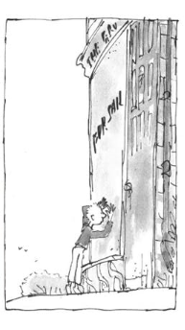
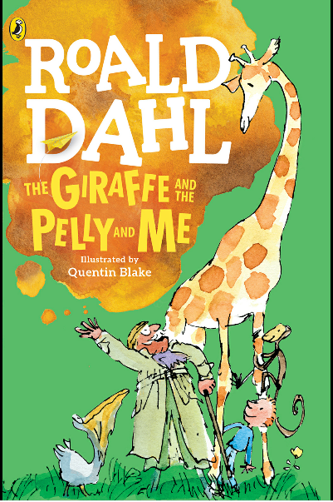

Let’s read the first part of the story together.

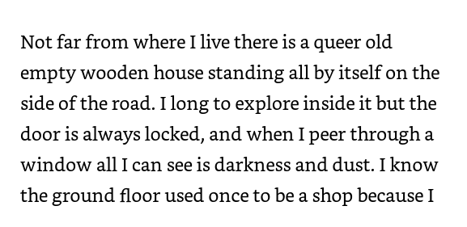
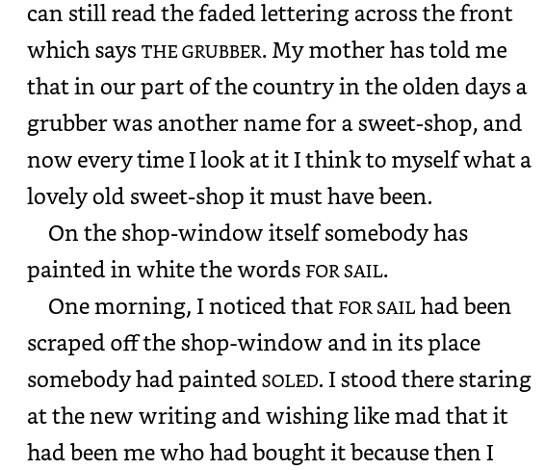
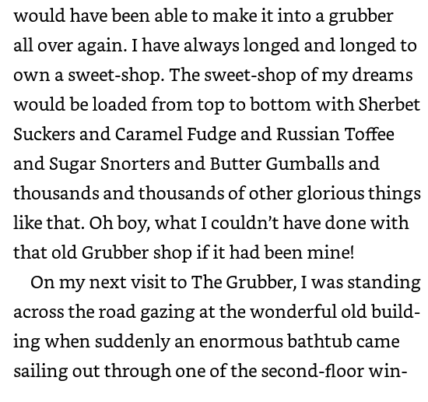

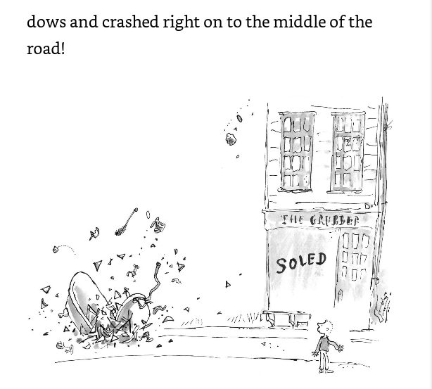
Tricky Vocabulary.
Short task:
Queer
Fade
Peer
Grubber

Can you find out what these words mean? Use a dictionary or a search engine on the computer.

Billy said it was his dream to own a sweet shop! How do you think he felt when he was looking in the shop windows? Do you think his dreams were dancing in front of his eyes? What was he imagining? What do you think Sherbet Suckers, Caramel fudge, Rusian toffee and Sugar Snorters are? Would you like to own a sweet shop?

Task:

WALT  I can show I understand the words in the text.  I can visualise the text.  I can infer feelings of a character through a picture.  queer, fade, peer, GRUBBER | 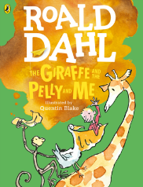
The Giraffe and the Pelly and Me
Fill in the picture to show what Billy may have said, felt and thought.

Challenge me: Draw a picture of what Billy may have seen through the shop window. Label it with adjectives and nouns (expanded noun phrases).

PSHRE 15.6.20
WALT: understand that money can be used for different purposes.
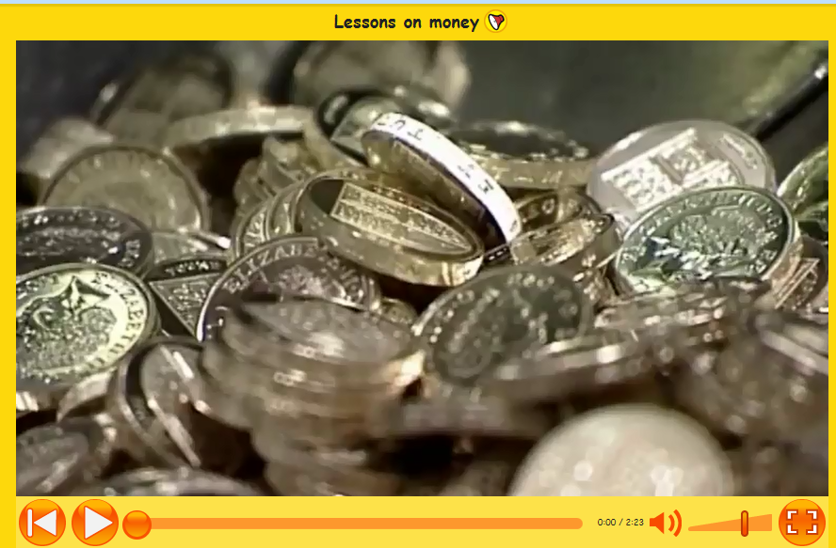

Watch this video on Espresso if you are able to:
https://central.espresso.co.uk/espresso/primary_uk/subject/news/video/item756483/grade1/index.html?source=search-PSHE-KS1-PSHE-all&source-keywords=money
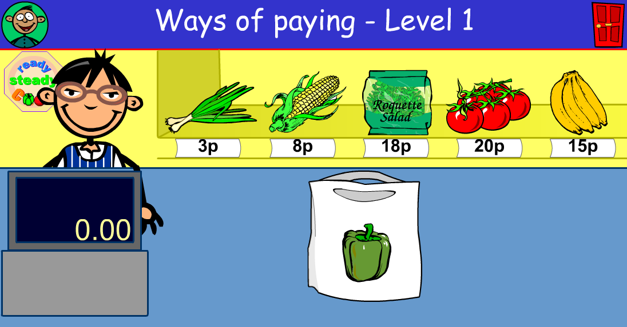
Play this game online:
https://central.espresso.co.uk/espresso/modules/m1_problem_solving/activities/act_ways_of_paying_l1.html

We spend our money on things that we need
but we can also save our money.
What do we need  to spend money on?  SPEND | What might we  want to save for?  SAVE

In last week’s story 'Sam and the Lucky Money'
Sam has cash to spend.
What other ways can we pay for things?

Do you know any other ways to pay for things?
What happens when our money has all been spent?

What happens if we borrow money that we don't get have?
If Sam had really wanted to have the basketball, what could he have done?
15.6.20 - Year 2 Music Summer Term 2 –
Consolidating Year 2 music learning – history of music, musical language.
Classical music
The term 'Classical music' has come to be known as a term for music that spans the course of hundreds of years, including all Western music from Medieval Church music, to Stravinsky, to the current day.
Listen to From The Diary Of A Fly by Béla Bartók - an orchestral composition from between 1926 and 1939 the 20th Century (Find this on the timeline). Stand or sit to ﬁnd the pulse or just listen to the music.
www.youtube.com/watch?v=ZVP1Nx1Aef0
The Composer - Béla Bartók (born in Hungary in 1881 and died New York City in 1945) was a famous Hungarian composer and pianist. He was one of the most important and original composers of the 20th century. He showed great talent as a pianist at an early age. He became very interested in folk music and travelled a lot in Hungary and other countries, including Romania, listening to the folk songs which the country people sang. He often used the style of these songs in his music. He is famous for his piano music, string quartets and several pieces for orchestra including one called Concerto for Orchestra . Bartók’s harmonies and lively rhythms were sometimes quite new to classical music and some audiences found them diﬃcult to understand at ﬁrst.
Bartók’s music used lots of modern sounds that can appear a bit odd if you are not used to them. They are called atonality, bitonality and modern harmonies. He often uses diﬀerent kinds of scales (not just major and minor ones), and very complicated rhythms
The story - The music describes a ﬂy caught in a cobweb, from the ﬂy's perspective, as he/she writes in a diary. You can hear buzzing sounds that signify the ﬂy's desperation to escape. In the end, the ﬂy does escape.
Rewind and Listen Out!
Listen to We Will Rock You by Queen – you will have heard this before.
What type of music is it? https://www.youtube.com/watch?v=FtyZSWJkFXU
What can you hear? You should be able to hear stamping, clapping, drums, male voice, group voices, electric guitar.

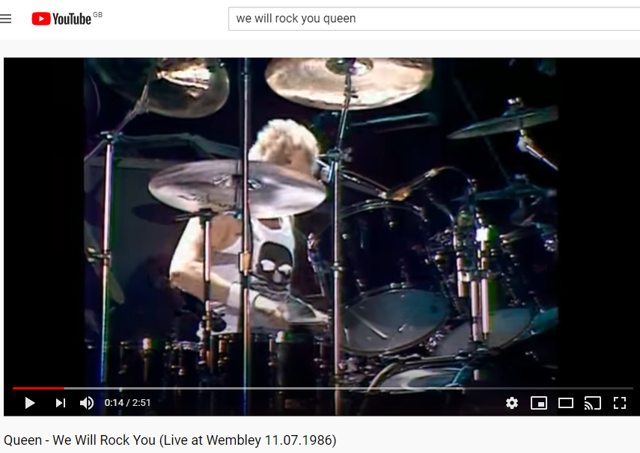
Can you talk about the similarities and differences between Classical Music and Rock music? Are the same instruments used?

