Year 2 Phonics/Spelling Practice – w/c 6.5.20 Wednesday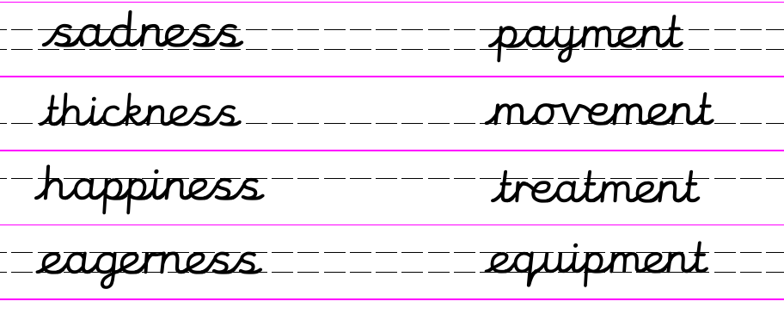
Use the grid below to make some more –ness words. Are there any you don’t know the meaning of? Ask an adult or look them up in the dictionary.
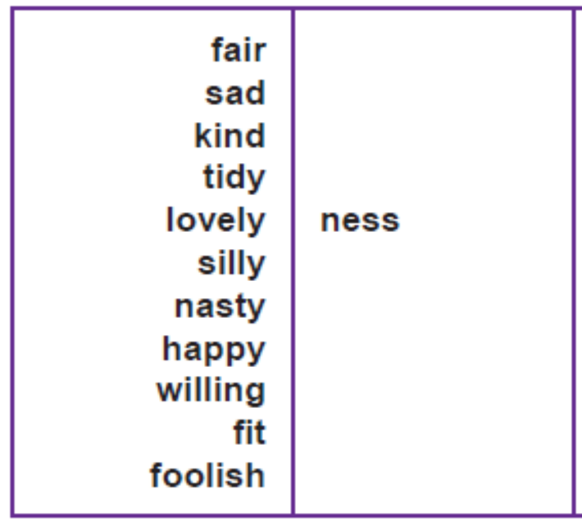

Remember the rule about words ending in –y!!!

Dictation sentence to practise:
With eagerness I looked at the thickness of the snow.

Maths 6.5.20
Test out your addition on this online game, if you are unable to get online, throw a dice to generate a two 2-digit numbers.
For example 4, 3, 1, 5 would be 43 + 15 =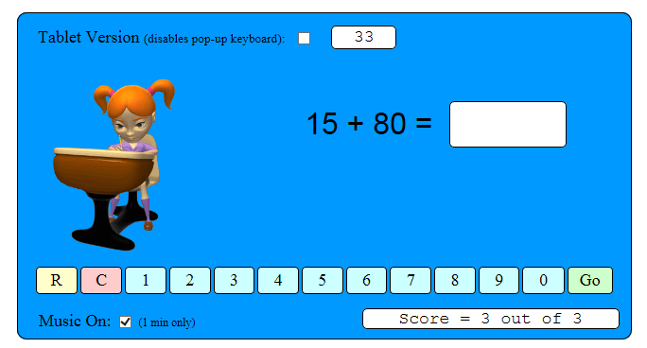
http://www.snappymaths.com/addsub/addsubp10/interactive/addm10to2d/addm10to2dint.htm

Use your drawing skills from yesterday to represent the 2-digit numbers when you add them. This will help you add accurately.
Remember: take care if the 1s make more than 10.
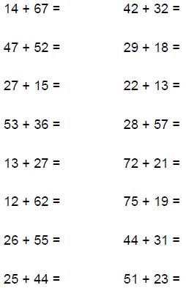
English - Wednesday 6th May 2020
Word of the week – ‘Summary’
Quote of the day
WALT: write a diary entry.
Good Morning. Can you believe another week has passed since we wrote our diary entries! My diary entry this week is from last week when I was lucky enough to be in school working with key worker children.

Dear Diary
I woke up to yet another beautiful, sunny morning. Can you believe it is only April and already the temperatures have reached over 20 degrees? It was an early start for me as I was going into Russell to work with the children of our Key Workers.
I set off at 8.00am and could not believe the change in traffic on the roads. Normally when I leave for school there are queues down to the roundabout but not today. I made it to school in record time. As I was about to get out of the car Mrs Hitchings arrived. Although I speak to her every day it was lovely to see her in person but extremely odd to have to stand at least two metres away from each other. We went in to the hall, washed our hands and started to set up the activities for the children who were in. There were only 7 which again felt extremely odd as the desks were set up in the hall. Each child was to sit on the end of a table and all the tables were two metres away. Once we had set the hall up Mrs Hitchings and I went to get a coffee. Mrs Appleby was in the office and it was lovely to see here and to have a catch up.
Once the children had arrived and the register and lunches taken I was lucky enough to read a story. The story was all about St George as it was St George’s day yesterday and the children were going to do some St George themed activities. After the story I had a meeting with Mrs Walker and Mrs Bunney. Before I knew it it was lunch.

I had decided to sit in my car to eat my lunch which I often do if I want a bit of peace and quiet.

In the afternoon we sat on the field and watched the children play p.e games with Mr Keech. It was very hot and we had to keep having drink breaks. After it was time for the children to do their home learning packs. It was lovely to see some children, particularly two boys from year 2. They are doing well and one of them has had a buzz cut,which looked great.
When I got home I couldn’t wait to share my day with the rest of the family as I am the only one who has been out to work. They were quite jealous!
It was a lovely day and although very different and far from normal one I cherished.

Mrs Johnson
R.E 6.5.20
WALT identify leaders in our local community.
Word of the day: community.

Last week we learnt about what makes people want to be leaders and what makes a good leader. We have started to identify some leaders who are inspirational to us. I saw a lovely picture one of you drew of a Nurse who was an inspiration to you. What a good choice!
We looked at how leaders have responsibilities and we identified what qualities made a good leader.
This week I want you to think about people in Ampthill who are leaders. One such example would be Mrs Walker. Your task is to think of at least five leaders in the community. A good start would be to think about any clubs you go to. Who is in charge?

Challenge me. Can you write a sentence saying why they are a good leader?

