Tuesday 16th June 2020
English
SPaG
Spellings – Words with a chuh spelt ture
Write each word in your spelling list backwards.
nature
future
pasture
gesture
mixture
picture
puncture
creature

Word of the Day – Limp

Definition ____________________________________________
_____________________________________________________
_____________________________________________________
Used it in a sentence: ____________________________________________________
_________________________________________________________________________
Word Class: ____________________________________________________
Synonyms

English
For your next piece of writing, you will be creating a text for a newsletter / online blog. Today you need to read the two texts below and then answer questions about newsletters and blogs. 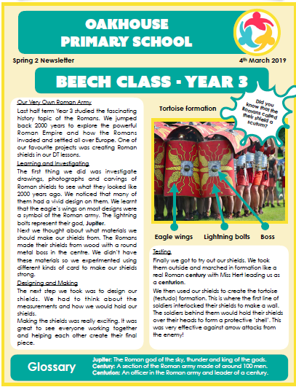

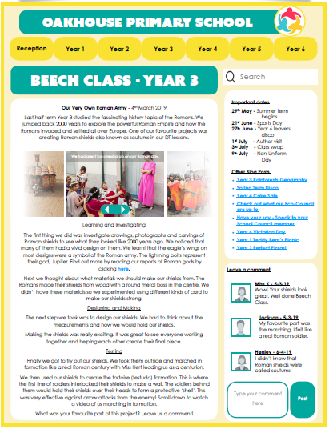

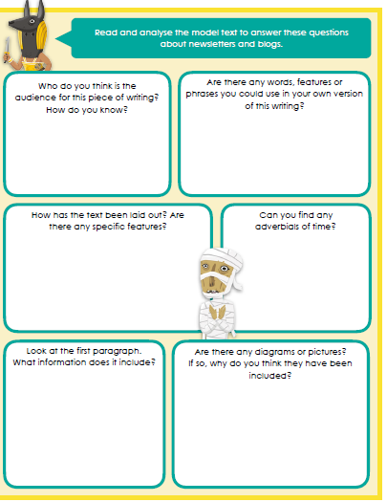
Maths Starter
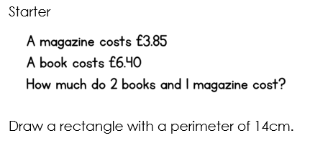

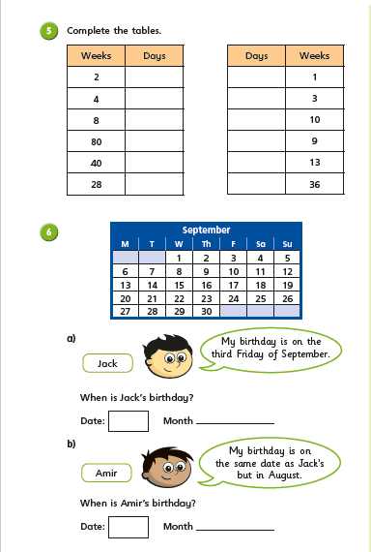
Main Lesson

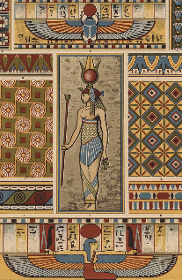
ART
Look closely at these Egyptian patterns. You can zoom in closely on the link below or choose some of your own patterns from google images. https://fineartamerica.com/featured/egyptian-textile-patterns-egyptian-school.html
Which colours are used most often?
Which pattern catches your attention? Why?
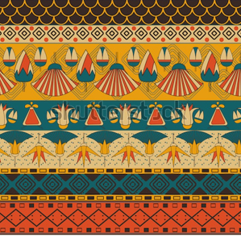
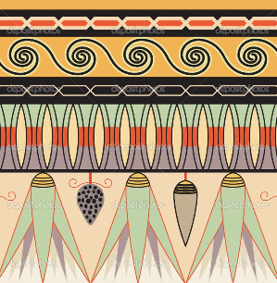
Can you spot a repeating pattern?
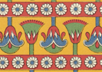

Task: Split your page into strips (or use the space below) and practice drawing your own Ancient-Egyptian-inspired repeating patterns.
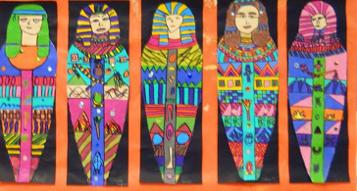
Challenge: Now that you have practiced some patterns, go ahead and decorate a sarcophagus of your own! Like this:
Tip: Free printable template on www.activityVillage.com

