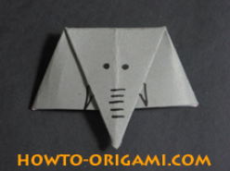
How to make an Origami Elephant
These instructions will tell you how to make an origami elephant.
You will need: A piece of paper and a black pen.
- First, carefully and neatly fold your piece of paper in half so that it makes a triangle shape.

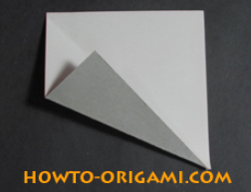
- Carefully, fold the bottom left corner to meet the diagonal line.

- Now, fold the top right corner to meet the diagonal line and neatly tuck in the top left corner to make a straight edge.
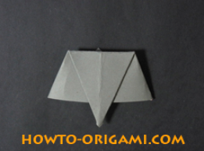
- Next, fold the bottom corner up to make an elephant’s trunk.

- Turn the elephant round so the tip of the trunk is pointing towards you.

- Finally, draw your elephant face and you have finished!

