Year 2 Phonics/Spelling Practice – Wednesday 10.6.20.
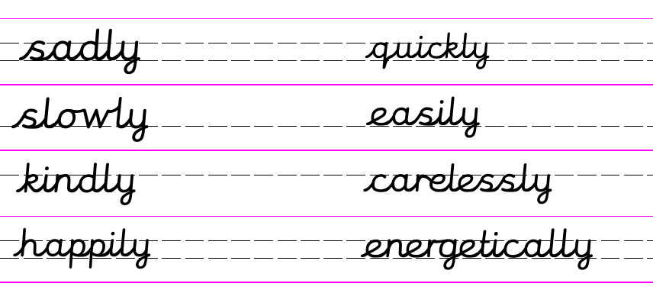
Look at these sentences.
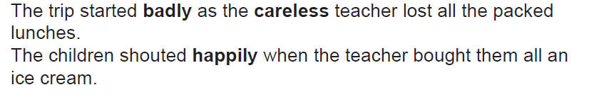
We know that the suffix -ly turns an adjective into an adverb.
ie. happy --> happily and bad --> badly

When we add -ly to the -ful suffix, it has a double 'l'
ie. hopeful --> hopefully

Try to make adverbs from these root words and then try with the suffixes –ful and –less too.
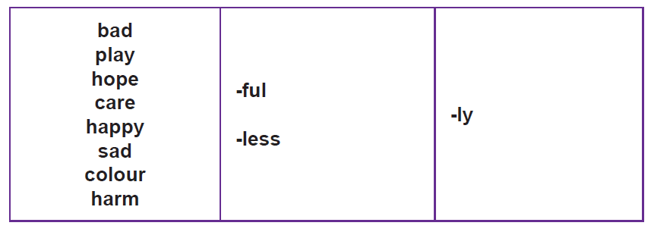
Maths 10.6.20
Sharing
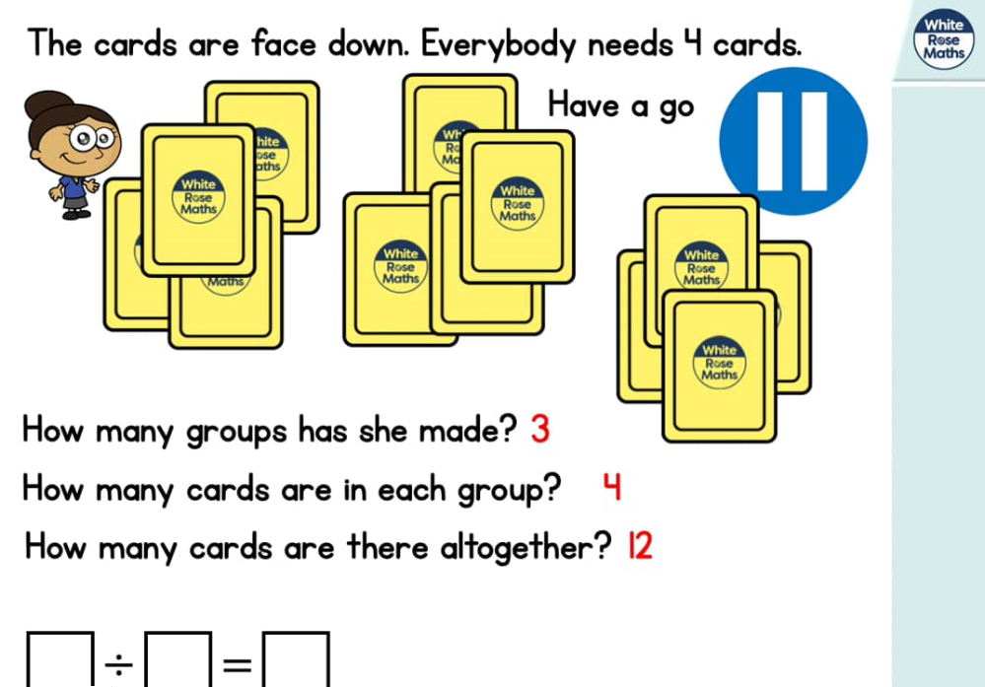
https://whiterosemaths.com/homelearning/year-2/ (Week 6 W/C 1.6.20)
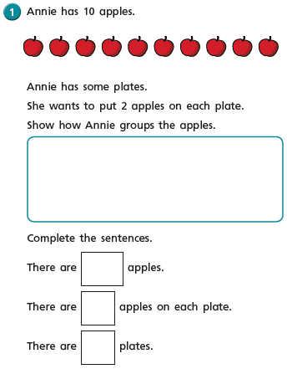
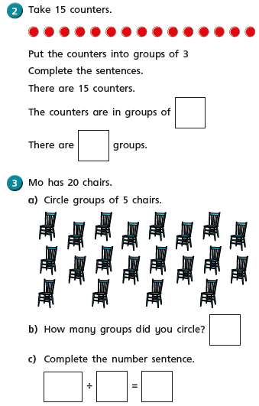

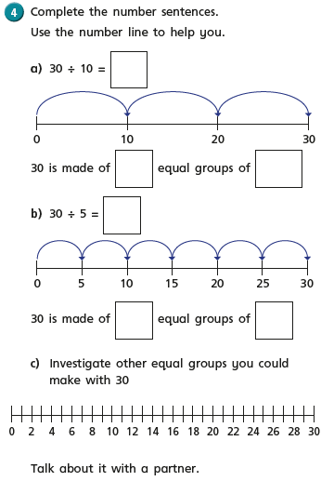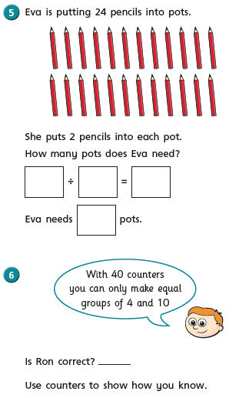

Wednesday 10th June 2020
WALT write a diary 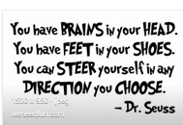

As always on a Wednesday, I share my diary entry with you but it feels very odd to share my day with you, now I am back at school and you are all still at home, staying safe and waiting to come back. So I won’t write a diary entry today about life at school unless you would like to know what is going on. So today you can choose to do your own diary or you could write a diary in the day of the life of………………………. It could be anyone; an astronaut, a famous footballer or athlete, a character in a book, anything that inspires you to write.
Look back at the diaries you have written over the past few weeks.

Did you write in the past tense?

Did you write in chronological order?

You could instead of writing draw a story map of your time in lock down if you would like. I received some amazing photographs of one little boy’s lockdown activities and they were brilliant. I looked at the photographs and felt that I knew exactly what he had been doing during lockdown! There were very few words,sentences but I could still tell how much he had learnt during lockdown. Things that we could never have taught you in school.
Cookery skills
Social skills – making new friends.
P.E – getting out into the surrounding countryside.
Geography – exploring new places in the local area.
The list goes on and on………………………….
So remember you can write a traditional diary, a diary in the life of someone else or put together a story map of your lock down or a mini photo album.

RE – Wednesday 10th June 2020
WALT some people can change the world by giving good news and hope to others.

In R.E this term we will be investigating ‘The Good News that Christians believe Jesus brought to the world
Last week in R.E we thought about the ‘Good News’ that Christians believe Jesus brought to the world. I thought what would be really nice today is if we made a card or letter that we could send to someone else sharing some good news. The good news could be anything. I know Bettsie in Greenfinch Class got a new bike not so long ago that was lovely, good news. Can you all share the ‘good news’ you may have. Even in these difficult times when we are not together we have so much to be grateful for and such good things are happening to us every day. My good news this week is that I have managed to finish knitting a throw for the front room which I began some years ago. My son’s good news is he has learnt how to make his bed!
The good news can be anything that puts a smile on your or someone else’s face.

You can write a letter or send a card it is entirely up to you. Spread the good news.

