Year 2 Phonics/Spelling Practice – Friday 10.7.20.
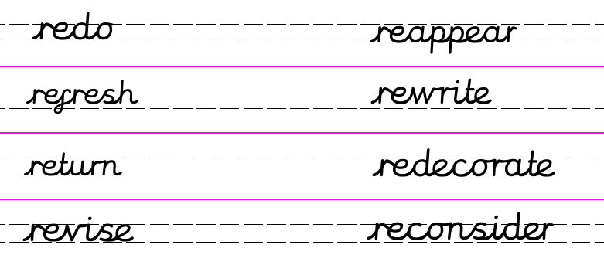
Create your own word search using words beginning with re-
Apply:
Write your own sentences using words beginning with re-.
_____________________________________________________________________________________________________________________________________________
Maths 10.7.20
Measure: Time – O’clock and half past

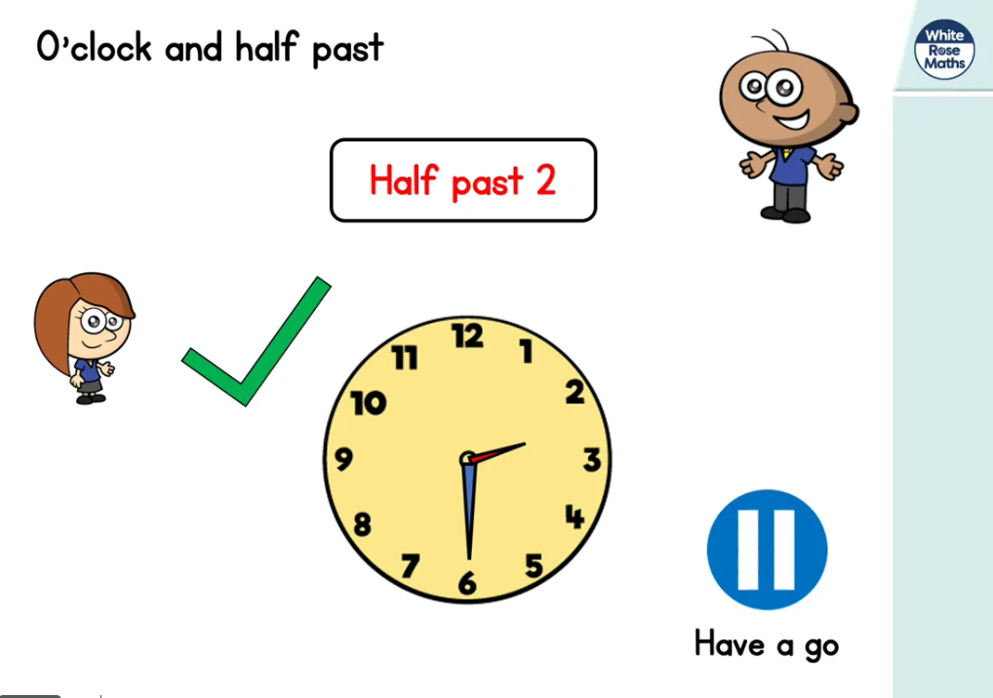
htps://whiterosemaths.com/homelearning/year-2/ (Lesson 3 w/c 6.7.20)
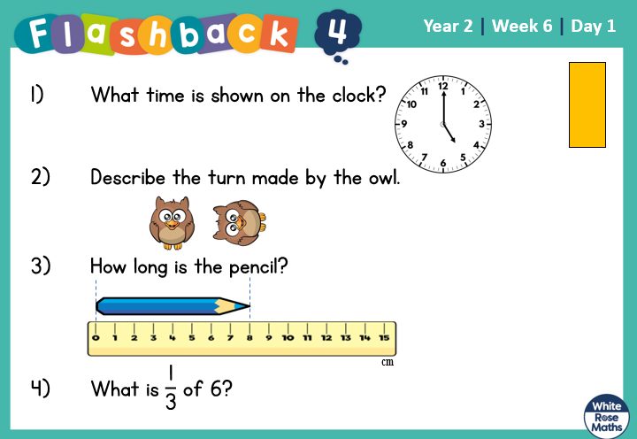

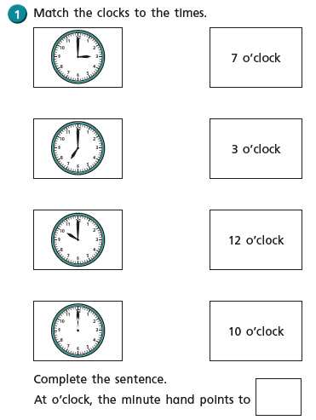

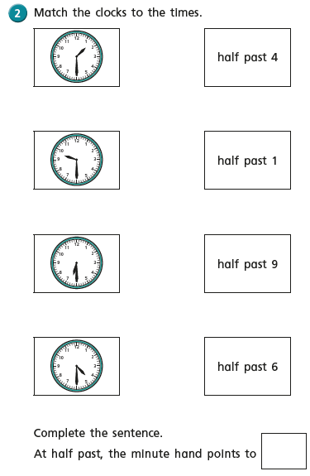
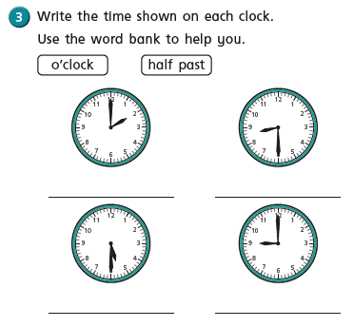
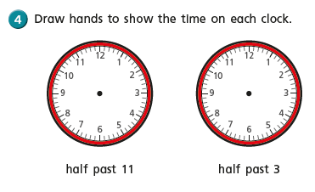
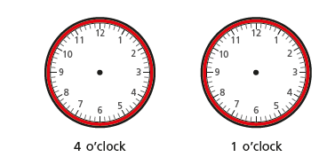
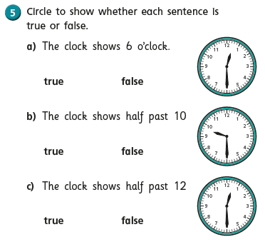

English - For the rest of this week we are going to concentrate on writing about our experiences from reading the book. We have three activities.
A blurb.
My favourite part of the story and which part you enjoyed the most and why.

Can you remember what we need to include in a blurb?
Which part did you like best? Why?
I hope you have enjoyed reading this story and have enjoyed the work set.

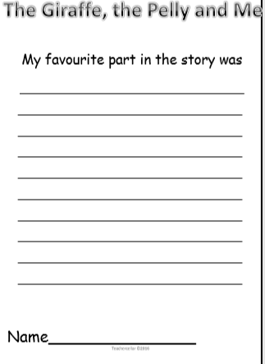
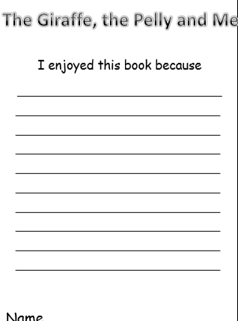
Computing 10.7.20
How games work
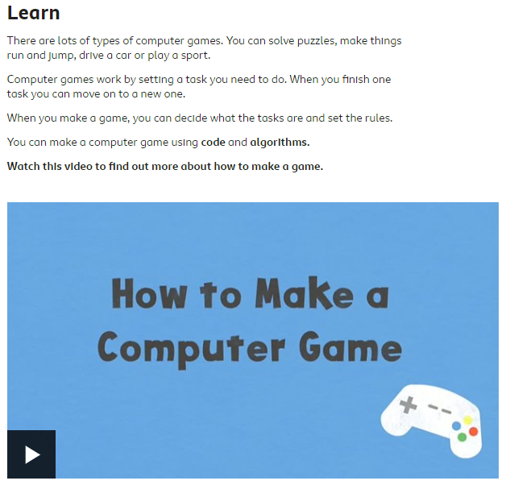
https://www.bbc.co.uk/bitesize/articles/zv6ybdm
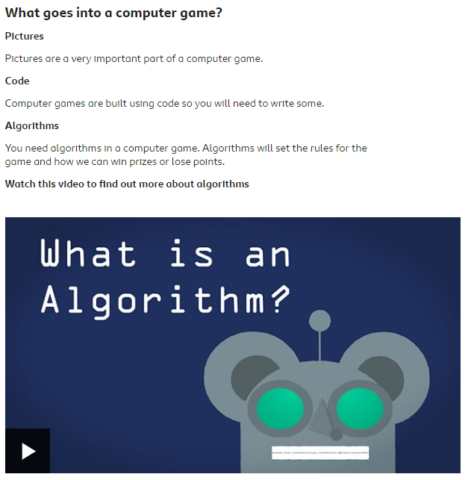
https://www.bbc.co.uk/bitesize/articles/zv6ybdm
