SEPTEMEBER NEWSLETTER
September 2021
Dear Parents/Carers,
Welcome to our first newsletter of the new school year. These newsletters are sent out on a monthly basis to keep you informed about what is happening in school. If you ever want to contribute an ‘article’ or suggest information that should be on the newsletters, I would be delighted to hear about them.
The children have been telling me all about their wonderful, and much needed, summer holidays and appear to be enjoying being back in school with their new teachers and friends. Everyone is looking very settled and learning has already begun at quite a pace! We are all enjoying the new freedoms we have been afforded too.
Please note events that are underlined and in italics are new since the previous newsletter.
Wednesday 15th September – Half of new foundation stage children start school
Thursday 16th September – All foundation stage children in, Year 4 Samba Workshops
Tuesday 21st September – 2:30pm – Phonics Workshop with coffee for Y1 and Y2 parents - See below for more information, PTA meeting 8pm at the White Hart
Wednesday 22nd September – Parent Volunteer Session (1) – See below for more information
Thursday 23rd September – New Intake Meeting (1) for Foundation Stage (2022), 9:30am Now full I’m afraid, please see other meetings later in the term
Friday 24th September – Parent Volunteer Session (2) – See below for more information, PTA Krispy Kreme sale after school
Monday 27th September to Wednesday 29th September – Mindfulness Superhero Workshops for all, Bike to school week
Thursday 30th September – FS reading and writing workshop for Foundation Stage Parents with coffee ‘morning’ 9:15 – 10:30am, New Intake Meeting for Foundation Stage (2022) at 2pm (2), Year 4 Samba Workshops
Monday 4th October – Harvest Assembly TBC
Tuesday 5th October – Year 4 WW1 Day – TBC
Thursday 7th October – UIFSM Census Day – please see more information below, Year 4 Samba Workshops
Monday 11th October – Parents’ Evening 4:30pm to 7pm – exact format to be confirmed in due course
Tuesday 12th October – Parents’ Evening 3:45pm to 6:30pm – exact format to be confirmed in due course
Wednesday 13th October – New Intake Meeting (FS 2022) (3) at 9:30am
Saturday 16th October – PTA Community Litter Pick – more details to follow
Monday 18th October – 6:30pm Finance and Resources Governors’ Meeting
Friday 22nd October – Break up for half term

HALF TERM MONDAY 25th OCTOBER – FRIDAY 29th OCTOBER
Please see the school website for more dates beyond this
More detailed information on the above events will follow in due course

A warm welcome to our new children and families:
We are delighted to welcome so many new children and families to Russell Lower School this year. We pride ourselves on being approachable, supportive and professional, and strive to build strong relationships with children and parents. It is this partnership, which makes Russell Lower School unique. Please do not ever hesitate to come and see any of us if you have the slightest concern or query – we will always do our very best to help.

Staff Structure 2021/22:
Please see the school website for this year’s staff structure https://www.russell-lower.co.uk/website/whos_who/158

Covid Outbreak Plan and updated risk assessment:
Thank you for all your continued support with managing the Covid-19 risk in the community. We have had a great first week back, and really hope it continues!
I will continue to update you if anything changes locally, and with details of how we can begin to get parents back involved safely with events in school and volunteering this term. Covid rules changed again over the summer as I said in my last letter, but here is a summary of when we want your child in school please (basically, almost always!):

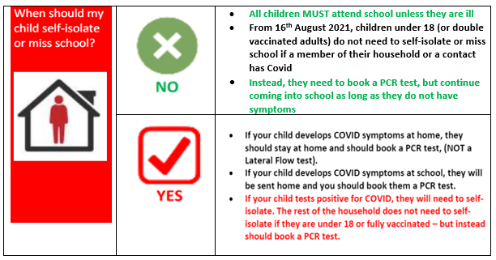
Our Covid Risk assessment and outbreak plan are now on the website. As always, please just come and ask if you have any queries.

Phonics Workshop with coffee – Year 1 and 2 Parents – 2:30pm on Tuesday 21st September
Ensuring children have good phonic skills is vital for reading, which unlocks the whole curriculum. Your child will have gained a great grounding in phonics in Foundation Stage and/or Year 1, and a partnership approach is the one we know works best for children. The government ‘screen’ all children’s phonic skills in KS1. This year, Year 2 will have this in December, Year 1 will have it in June 2022. If you would like to find out more about how to support your child with their phonics/reading at home and to support them with the ‘screening’, please join Mrs Jochacy (Phonics lead) for this informative session. Coffee will be provided! Please complete this very short form to save your place: https://forms.gle/Syy4wYQVdwzNfZuT7

Parent Volunteer Sessions – 3pm on Wednesday 22nd and Friday 24th September
As you know, since Covid reared its head, we have been unable to tap into the exceptional support of ‘parent helpers/volunteers’. We would really love to get this going again, but would need to ensure that we do not increase the risk of Covid coming into school and disrupting education as much as humanly possible. As a result, we request that anyone wishing to volunteer:
- Attends a short induction session to inform you about child protection, Covid measures and our Parent Volunteer Protocols
- Ideally, is prepared to take part in our twice weekly lateral flow and reporting process
- Ideally, has had two vaccinations (as otherwise you still need to self-isolate following any ‘contact’)
- Already has, or is prepared to have a DBS (disclosure and barring) with Russell Lower School’s name on it (ones from previous years are still fine)
Everyone MUST attend an induction session and MUST have a DBS in place before working with the children. The Covid criteria would not necessarily prohibit you helping in class, but would mean that we would need to undertake an individual risk assessment which is why we are requesting the information. If you would like to volunteer in school this term, please complete the following Google form prior to 19th September, to save your place on one of our short inductions. Thank you. https://forms.gle/XxHmLWQucEvUAiCz6

Foundation Stage reading and writing workshop with coffee – Thursday 30th September, 9:15 – 10:30am
This workshop is for our new Foundation Stage (Doves, Swifts and Swan Class) parents to learn more about how we teach reading and writing at Russell Lower School, along with how you can support us from home. Please do come and meet Mrs Brown in the main hall. . Coffee will be provided! Please complete this very short form to save your place: https://forms.gle/U1ne23vEYGKxwwqF8

Free School Meals ‘Census’ Day:
You will be aware that school budgets are getting increasingly ‘squeezed’ by the government, and one way we can maintain our budget is by making sure we are using what the government currently provide. Universal Infant Free School Meals are currently made available to children in FS, Y1 and Y2. From Y3, parents are asked to pay for school meals. Please note: sadly, prices have increased from £1.95 to £1.99 this academic year, due to increasing costs. In order to keep this free lunch facility, we have a ‘Census Day’ to check our use. This day is Thursday 7th October. If our percentage of meals eaten on that day is high it results in more money coming into the school budget. This is crucial in maintaining current standards. Please support us by encouraging your child to have a school dinner on that Thursday (we have changed the menu to make it as attractive as possible to as many as possible and Mrs Bremner will be sending you a separate letter to give you this information). With your support we can make sure Russell continues to receive the highest possible percentage of the available money so the children continue to benefit. Thank you.

Is your child interested in learning to play an instrument?
There are currently some spaces available for some of our musical instrument lessons with peripatetic teachers from Central Bedfordshire’s Inspiring Music. Lessons are offered for flute, fife, violin, viola, piano, guitar, cello, brass instruments and drums. Mrs Perry has spaces for children to play the violin. If you are interested in your child learning an instrument and would like more details please contact the school office. Alternatively, if your child is interested in learning to play a woodwind instrument (flute, fife or recorder), more information is available on www.inspiringmusic.co.uk and instruments are available to loan.
Miss Alsop (teacher) would be more than happy answer any questions you may have, her email address is rosie.alsop@centralbedforshire.gov.uk

Collection of children:
The school day finishes at 3:30pm. Do not worry, if you have several children to collect, we will always keep them safely with us until you arrive. If your child is collected by anyone other than their parents, could you please ensure that your child’s new Class Teacher is made aware of this. Any changes to the normal collection arrangement of your child should also be notified to the school office please (not the class email address as this cannot be checked regularly during the day). As your child’s wellbeing and safety is paramount, no child will be released without prior parental consent of any changes or if anyone under the age of 16 comes to collect them. Should your child need to be collected during the course of the school day please can you ensure your child is signed out at the school office? Thank you.

Supporting learning at home:
Thank you for your support with the numerous ways you enable your child’s learning at home. Your time and effort are invaluable and makes a HUGE difference.
Over the next few days (or already, in Y1, 2,3 and 4) we will be providing you with some information that we hope you will find useful:
- Theme webs for each year group to show you what children will be learning this term.
- Home learning letters to explain what ‘homework’ children will be asked to complete in each class and other ways you can support learning from home. This will also detail when it is due in. Thank you for your support with this.
School Safety:
Please can we ask all parents who come and go through the main Queens Road entrance path gate during the school day to ensure they close not only the latch on the gate, but also then CLOSE THE HOOK too. This ensures all our children are as safe as possible. Thank you.

To parents of Greenfinch and Wren Class – Please be aware that we do request that pushchairs are not brought inside school for Health and Safety reasons, as the corridors are too narrow. I apologise for this not being made clear before the children started back last Monday. We forget that parents haven't been in school for a long time! Thank you for your support.

School admissions to Foundation Stage in September 2022 and Middle Schools:

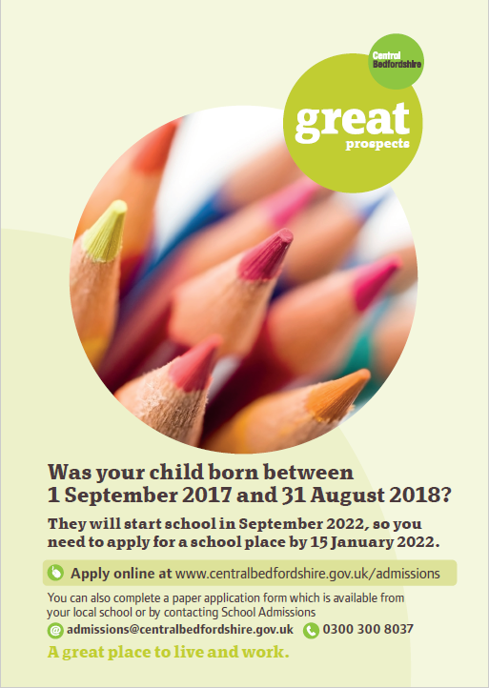
It’s that time of year again!

Children born between 01/09/17 and 31/08/18 are due to start school in September 2022.

Parents/ carers need to make an application to CBC by 15 January 2022, even if their child attends a nursery/pre-school on the school site.

All the information you will need regarding your Starting School 2022 application is available on the CBC website.

Please bear in mind that applications for Middle School are also needed within the same timescales i.e before 15th January 2022.

School admissions | Central Bedfordshire Council

Community events

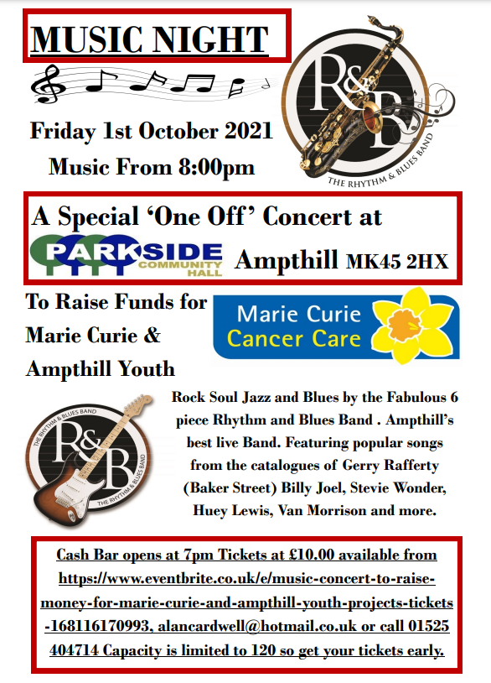
And finally
Thank you for taking the time to read this (very long – sorry) first newsletter, and for making the first week back go so smoothly. I look forward to an exciting and productive year at Russell.
Many thanks and kind regards,
Nicki Walker
Headteacher

